**On the Evaluation of Conditional Cash Transfer Programs**

*An analysis of CCT programs and poverty*

Pedro Ávila

April 2012

Quantitative Methods Thesis

Columbia University

Abstract

Conditional Cash Transfer programs are the popular government welfare paradigm of the new millennium, the main objectives of which are to lower poverty levels in the short term by distributing cash, as well as to decrease poverty in the long term by incentivizing program participants to build the human capital necessary to support themselves without program benefits. Though these programs are not a singular answer to the eradication of poverty, they are praised as innovative and necessary tools of welfare. Their popularity and relative novelty have captivated the attention of both academics and practitioners, and as a result, their effects are widely studied. Specifically, their effects on improving health, education and social outcomes are thoroughly documented.

A key element is missing, however, in the ongoing effort to evaluate these programs. Evaluations that discuss the programs’ outcome potentials in the long run must show that poverty levels in countries where these programs have been implemented sustainably decrease. Using generalized poverty data from the World Bank as well as figures for Brazil’s CCT program, *Bolsa Família*, this analysis uses time-series methods to show that while levels of poverty have decreased in countries implementing CCT programs, there is little evidence that CCT programs promise to be as effective in combating poverty in the long term as many would like to believe.

*Acknowledgements*

A heartfelt thanks to Greg Eirich for his role as unofficial advisor on this thesis, and for his patience and support throughout the classes I took from him.

*Obrigado, Vô, pelo exemplo de disciplina, caráter, integridade e erudição na simplicidade.*

Thanks, Boy, for the unconditional companionship, even from afar.

Thanks to my fiancée, Laura, for having the utmost confidence in me at every single step, for talking through the frustrations and raw thoughts, for putting up with and encouraging my late nights and early mornings, and for keeping me loved, focused, fed and turned towards the sun.

And thanks mom and dad for the last 30 years of all that. It seems I’m in good hands.

*For my first family, and my next one*

*Mom, Dad, Boy & Laura*

# Table of Contents

1 Introduction 1

CCT Program Overview 3

CCT Programs in the World 5

Addressing Poverty 8

Objective & Hypothesis 9

2 Literature Review 11

Evaluating Apples & Oranges 13

Poverty Metrics 17

Measuring Levels of Poverty 18

Measuring Change in Poverty 21

Measuring Long term Poverty Reduction 23

3 Data & Methods 28

World Bank Dataset 29

Treatment of Data 30

Data Description 33

Method 35

Exogenous Factors 37

4 Observations 40

Naïve Analysis 43

5 Analysis & Discussion 46

Brazil 46

Other Countries 49

Discussion 53

Issues & Limitations 54

6 Conclusion 57

7 References 59

8 Appendix 64

Foster-Greer-Thorbecke Index of Poverty 64

# 

# Introduction

With the transition into the millennium well underway, the conditional cash transfer (CCT) model for welfare programs that emerged in the late 90’s has begun to spread from its cradle in Latin America to the rest of the world (Figure 1). In 1997 three such programs existed around the world in Brazil, Mexico and Bangladesh (*Bolsa Escola*, *Progresa* and *Food-for-Education*, respectively[1]). Today, virtually all countries in Latin America and various others around the world have implemented CCT programs, and many others are in pilot or discussion stages of deploying some variant of a conditional cash transfer scheme as a measure against poverty (ILO 2009).

Figure 1 — CCT Programs in the World

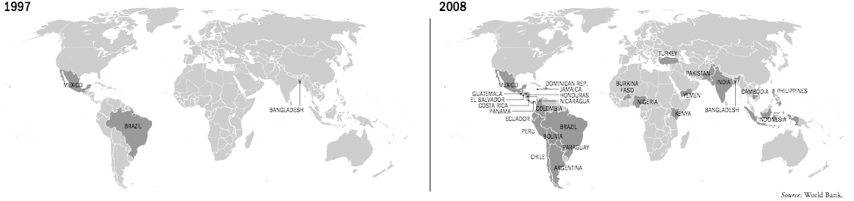

These programs are continually evaluated, both by the program administrators who have a vested interest in the programs’ success as well as by third party organizations such as the World Bank, the United Nations, the International Monetary Fund and other institutions with an interest[2] in the programs (Attanasio et al. 2005; Britto 2005). While the results of existing studies generally point to successful outcomes[3], if we are to acknowledge these claims by continuing to expand the programs, we should have a better idea of what they can reasonably deliver. Because of their explicit mandates we should not expect that programs will be funded solely for their tendency to improve poverty related metrics[4]. It may not even suffice to prove that poverty levels decrease with the implementation of a CCT program. Instead, evaluations that strive to demonstrate the effectiveness of CCT programs must show that not only are CCT programs associated with a decrease in the immediate levels of poverty, but also with an increasingly negative rate of change in poverty levels.

CCT Program Overview

CCT programs distribute cash to eligible and registered beneficiary families as long as the participants continue to meet conditions designed to promote social interests falling under the term *human capital* (François Bourguignon, Ferreira, and Leite 2003; Fiszbein et al. 2009; Rawlings 2004). Eligibility is usually defined by the number of children a family has below a certain age threshold and whether the combined family income falls below a certain poverty line. The programs are designed to promote qualities and characteristics in its citizens — their human capital — that are generally believed to lead to healthier societies. For example, these include keeping children enrolled in school and properly vaccinated, as well as providing evidence of regular preventive health care (Fernald, Gertler, and Neufeld 2009; Fiszbein et al. 2009). Programs see these principles to implementation differently, with some putting more emphasis on educational measures such as high enrollment figures, while others focus more on child nutrition, or family consumption (Attanasio et al. 2005; Attanasio et al. 2008; Rawlings and Rubio 2005; Freije et al. 2006).

In contrast, traditional directed government welfare provides a specific kind of aid to the poor. Medicaid, for example, provides the poor with a means to obtain health care while rice subsidies provide the poor with a means to obtain food. Such programs provide no options for the poor to restructure their lives, and if the benefits do not suit the specific needs of the beneficiaries, the program provides no relief for them. The beneficiary may not, for example, be able to find transport to a Medicaid clinic. Likewise the price of rice may increase. Additionally, non-CCT programs may provide immediate relief, but they fail to address poverty in the long term. Food stamps or rice subsidies, for example, provide immediate relief to the poor with the purchasing power to buy food, but short of continuing to provide benefit, do little to eradicate the generational transmission of poverty.

Cash transfer programs, on the other hand, provide cash directly to the beneficiaries to alleviate immediate burdens of poverty[5]. Conditional cash transfer programs go one step further, taking measures to encourage forward-thinking decisions (Rawlings 2004). Common across every variation of CCT program are the conditions that beneficiaries[6] enroll their children in school as well as maintain a regular schedule of health check-ups, as these are widely held to be the most critical factors of sustainable poverty decrease (McKee and Todd 2011). Ultimately the aim is to build up future generations’ levels of human capital and earnings potential and in a sense, these programs ask for a return on society’s investment, providing an incentive (or a mandate, if enforced) for beneficiaries to do their part in alleviating poverty from society in the future. CCT programs posit that as beneficiaries leave the program, they should be better fitted with the tools necessary to lift themselves out of the cycle of poverty and into the middle class (Fiszbein et al. 2009; Grosh et al. 2008; Rawlings and Rubio 2005; MDS 2012).

CCT Programs in the World

Although CCT programs have had successes in regions with widespread and extreme poverty, they are commonly deployed in developing as well as developed nations (Handa and Davis 2006; UNDP 2009). First pioneered in Mexico and Brazil, the countries’ respective CCT programs, *Oportunidades* and *Bolsa Família*, continue to lead the world in program scope, reach and evaluation results (Lindert et al. 2007). Other developing countries such as China and India have pilot programs that continue to adjust and expand. Even in the United States, the city of New York developed *Opportunity NYC*[7] to lessen immediate income-related hardships for low-income families through cash transfers as well as to encourage and help low-income families to increase and sustain positive efforts to improve their futures by investing in their children (ONYC 2012).

The popularity of CCT programs in recent years is easy to see, when even the media response to them is a topic of study (Lindert and Vincensini 2008). As *the* hot ticket item in social welfare policy, CCT programs have a broad base of support, their successes the subject of much optimistic reporting that is widely disseminated by the media (Britto 2005; UNDP 2009). Compared to other social welfare programs such as unconditional cash transfers (or near-cash transfer such as food), general subsidies, workfare or fee-waiver programs[8], CCT programs are flexible and well-studied in concept, as well as efficient and transparent in their implementations, focused on the future with a clear set of goals (Rawlings and Rubio 2005). It’s also easy to understand why the programs have such levels of support given that they provide what the public and its politicians want. The poor get a program that provides cash directly in their hands, while the taxpayer is appeased with the conditions that the program requires of its beneficiaries, as well as being reassured of the program’s positive effects from the successful metrics of the myriad existing studies. Politicians, in the meantime, are given the opportunity to fund an already popular program that will provide renewable support at a low cost of implementation (Fiszbein et al. 2009). Still, popularity today does not equate to evidence of success in achieving long term goals.

Nor is it any surprise that CCT programs are so widely studied. Given the relative novelty and reported success of the programs in places like Brazil and Mexico, it makes sense that governments interested in deploying similar programs take a keen interest in the outcome of existing programs (UNDP 2009). As the largest and most popular programs, Brazil’s *Bolsa Família* and Mexico’s *Oportunidades* are particularly well-studied (Britto 2005; Dammert 2009; Rawlings and Rubio 2005). And while the literature on CCT programs and program evaluations is pervasive today, Cardoso and Souza noted in 2004 that few ex-post studies existed for CCT programs in Brazil (Cardoso and Souza 2004). In 2003, however, the popular and reportedly successful municipal CCT programs in Brazil[9] were merged into *Bolsa Família*, Brazil’s popular flagship program (Caixa Economica Federal 2012; World Bank 2012). The resounding reports of the successes of the Brazilian program in improving social welfare indicators — such as school enrollment and preventive care given to children ­— opened the proverbial floodgates. By 2005 the number of studies, outcome analyses and evaluations of CCT programs had greatly increased (Lindert and Vincensini 2008), and funding was more widely available for new initiatives (Fiszbein et al. 2009; Grindle and Thomas 1991; Britto 2005). Given the sizable funding opportunities at stake and the relative size of CCT programs (Johannsen 2009), these programs naturally began drawing the attention of evaluators, particularly the larger ones, like *Bolsa Família*[10], which by 2011 reached 11.1 million people, almost 25% of the country’s population (Lindert et al. 2007)

Addressing Poverty

Poverty is a multi-faceted phenomenon, with many causes, effects and — hopefully — solutions. A study of poverty, therefore, requires clarity concerning definitions and terms. According to the World Bank, poverty can be broken down into three categories[11]: resource poverty, inequality and vulnerability to poverty in the future (World Bank 2012). Issues pertaining to the measurement of poverty across these categories are important considerations when selecting data. Because I use poverty data provided by the World Bank[12], these dimensions of classifying poverty are already accounted for in the figures (World Bank Data 2012).

In order to measure poverty directly, I quantify and label it across countries by using the Foster-Greer-Thorbecke (FGT[13]) family of indices, which is used to quantify poverty in several other studies of note (Fiszbein et al. 2009; Grosh et al. 2008; Freije et al. 2006; UNDP 2009). A relatively simple trio of poverty metrics, it requires no control group as it relies on a fixed poverty line (Fiszbein et al. 2009; Foster, Greer, and Thorbecke 1984). Although the World Bank uses an international poverty line of purchasing power parity (PPP) $1/day to categorize extreme poverty, in this study I select the poverty line at PPP $2/day because it is more relevant to lower-middle income countries such as Brazil, which is the country of focus in this study (Ravallion 2008). The higher the FGT statistic, the more poverty there is in an economy. A breakdown of the three components of the FGT family is discussed in the appendix.

Objective & Hypothesis

Few studies of CCT program outcomes have addressed poverty outcomes directly, even though the main goals of CCT programs are to alleviate poverty in the short and long term (MDS 2012; Caixa Economica Federal 2012; Fiszbein et al. 2009; Grosh et al. 2008; Rawlings 2004). As such, no clear answer has yet emerged to address the question of whether CCT programs are achieving these goals (Grosh et al. 2008). Using macroeconomic data to observe the rates of change in poverty levels I show that CCT programs are associated with a sustainable decrease in poverty levels.

Certainly these programs will have helped people overcome real obstacles and improved the lives of beneficiaries. CCT programs have been attributed with increased participation in the political process as well as drops in income inequality (Gledhill and Hita 2009) and other studies show that CCT programs have had a clear effect on height-for-age[14] (McKee and Todd 2011; Gladwell 2008). Studies also show that CCT programs have an impact on increasing school enrollment (Schultz 2004; Cardoso and Souza 2004). However, Bourguignon, Ferreira & Leite (2002) show that while *Bolsa Família* had an impact on school enrollment numbers in Brazil, there was no correlation with a decrease in child labor statistics or an increase in school attendance, implying that human capital might not be increasing as the programs intend. Taken together, these data suggest that there may be a gap between what the programs are meant to do and what they are, in fact, doing.

Given these indicators and how the issue of poverty in particular has not yet been explicitly addressed, in this study I address the issue of whether the implementation of CCT programs is associated with a decrease in poverty levels. I conduct a difference-in-difference analysis of the poverty levels in Brazil from 1980 to 2011 to provide evidence that there exists a difference in the rate of change of poverty levels before and during the different stages of the *Bolsa Família* CCT program, showing explicitly that the rate of change has been increasingly negative. The results of this analysis are compared to a similar analysis of other countries with and without CCT programs to validate the trend.

# Literature Review

Although the existing literature examining CCT program outcomes and impacts contains significant evidence to support an improvement across many indicators of social welfare, few studies reach any conclusion about the association of CCT programs with poverty reduction. Data quality is certainly an issue — gathering poverty data is inherently difficult and costly (World Bank Data 2012). Moreover, though some program participants have already exited the program, CCT programs as a concept have been around for little more than a decade (Caixa Economica Federal 2012). What this means is that measuring rates of change in poverty levels through the observation of proxy variables (such as education and health) is inefficient and unlikely to yield results (Wooldridge 2009). A study of *Bolsa Família’s* impact on Education and Labor performed by academics at the Federal University in Minas Gerais — as one of many examples — used data from the initial Impact Evaluation of *Bolsa Família* (AIBF) survey from 2005, only two years after the program’s inception in 2003 (Oliveira et al. 2007). Oliveira herself recognizes that the quantity of data available at that time was insufficient to satisfactorily perform time-series analysis, and casts doubt on the validity of the claims.

Regardless of whether due to data quality or availability, studies of CCT programs have tended to focus on social welfare metrics directly than on explicit poverty. Attanasio’s evaluation of Colombia’s *Familias en Acción*, for example, asserts the program’s effectiveness in increasing consumption within households and highlights other promising figures concerning educational enrollment and vaccination rates, without referring to the general levels of poverty (Attanasio et al. 2005). Similarly, Fernald’s assessment of *Oportunidades* reiterates the claims of the program’s success in Mexico but does not include a metric of poverty in the study (Fernald, Gertler, and Neufeld 2009). In another example of this treatment of social welfare indicators over poverty metrics, in different papers Rawlings thoroughly asserts the impacts of CCT programs on social welfare metrics including education, health and consumption, but for various reasons including data quality and availability, falls short of being able to conclude anything about the programs’ explicit impacts on poverty (Rawlings 2004; Rawlings and Rubio 2005). It is important to question whether this pattern of failing to address poverty directly merits concern because although the programs are clearly having a positive impact on *something*, the allocation of resources is always an important consideration (Mankiw 2010).

An increase in the metrics of overall social welfare is not necessarily correlated with a decrease in poverty levels in the long run. While research shows that patterns of consumption by the poor have changed in countries with CCT programs, and that recipients of benefits are spending more on the education and well-being of their children[15], this metric alone says nothing of the social capital being built by the beneficiaries, and therefore we do not learn anything about the sustainability of the poverty reduction created by the programs. Similarly, though there is evidence of increases in the use of preventive health services and school enrollment (Fiszbein, Schady et al. 2009), changes in these indicators — positive as they may seem for social development — are not necessarily evidence of decreasing poverty. Health and education improvements must be complemented by supply-side interventions in order to ensure real gains in human capital development (Fiszbein, Schady et al. 2009). And while the effects of CCT programs seem to clearly increase the demand-side pressure on these services, conclusive evidence that this pressure has resulted in the necessary supply-side improvements to continue the capital construction has not yet emerged (Grosh et al. 2008).

Evaluating Apples & Oranges

CCT programs share the fundamental idea that cash given to the poor can be an investment in building the human capital of society. However, the implementations of programs across different countries, populations, geographies and political constructs are far from identical, and measuring how one program compares to another is not straightforward (Fiszbein et al. 2009). Even in Latin America, economic, social, political and geographic differences preclude a homogeneous take on the design and deployment of a country’s CCT program. In Peru and Bolivia, for example, targeting and delivery methods needed to be modified in order to account for poor populations in difficult mountainous terrain not easily reached nor often traversed (Borraz and González 2009). The authors note that this change in deployment methods had an observable effect on the measured impact a few years later when the Uruguayan program evaluators tried to compare their results with the Peruvian and Bolivian findings and found too many inconsistencies and deviations from expected values. The targeting conditions and methods used in Peru and Bolivia turned out to be too different for the results to be fairly compared with their own, which took into account the reasonably low-altitude and homogeneous terrain of Uruguay.

Program evaluators must also be aware of the wording used when relying on surveys, interviews or other qualitative methods of evaluation. Social perspectives can differ drastically between neighboring countries such as Brazil and Argentina (and even within them)[16]. Between countries of differing fiscal and social leanings there will be different perspectives on the value of the conditions of a CCT program and therefore on how they will internalize their social responsibility. Lindert and Vincensini note that politically left-leaning countries see the conditions as merely emphasizing citizen’s rights and responsibilities whereas more right-leaning countries see them as enforceable contracts between beneficiaries and the tax-paying public (Fiszbein et al. 2009; Lindert and Vincensini 2008). Since voters are not utility-maximizing game-theorists, and are even less so in more left-leaning countries than in right-leaning ones (Britto 2005), their study finds that public support for CCT programs changes depending on the most politically palatable language used when referring to the conditions. An electorate that sees government as its agent and welfare as a social responsibility to its underclass might more easily support a program that is labeled with co-responsibilities.

On the other hand, in a society that views government as authority, groups receiving benefits may understand and more reliably comply with a program where the tradeoff is labeled as a condition (Fiszbein, Schady et al. 2009). A study in Kenya, for instance, found that even though the incidence of malaria decreased when households were provided mosquito nets treated with insecticide, when asked about what they would do given an equivalent amount of cash, households responded that they would have spent the aid on different priorities such as food and clothing, showing little import to the idea of a social responsibility to help prevent an epidemic (Das, Do et al. 2005). Conversely, in Brazil, a country whose government and media engages in pervasive campaigns to increase people’s awareness of their citizenship and contributions and effects within the society[17], interviews with program participants indicate they are proud to be able to keep their children vaccinated and enrolled in school and still be able to afford food and housing for their families (Caixa Economica Federal 2012; MDS 2012).

Generalizing results of studies like these is difficult, of course, because many CCT programs are designed with emphasis on different aspects of human capital construction (Rawlings and Rubio 2005). Colombia’s *Familias en Acción* program focused on improving patterns of consumption among the poor (Attanasio and Mesnard 2006) while *Oportunidades* in Mexico had a strong education-centric component (Schultz 2004). Even though these programs share the goals of reducing poverty in the short and long term, when governments deploy them across different types of environments to people with different cultures and values experiencing different types of poverty, it is reasonable to expect that the implementations and outcomes will differ in meaningful ways. Evaluating program successes based on comparisons of social welfare indicators that are difficult to measure or translate from one program to another complicates the task. Rather than measure the success of a program based on how it compares to that of another country’s, it is preferable to measure the results in a country using a measure that can be directly compared, such as the percentage decrease in that country’s rate of change in poverty over time.

Poverty Metrics

Because they are the most easily understood and widely reported, I will focus on the two elements of the FGT[18] index that are most relevant to resource poverty — namely, when α=0 and when α=1 (Fiszbein et al. 2009; McKee and Todd 2011; Grosh et al. 2008; World Bank 2012). Respectively, the FGT0 and the FGT1 represent the poverty headcount ratio (or the proportion of a population considered to be poor) and the poverty gap (a measure of the depth of poverty). Drops in either of these figures indicate a decrease in the levels of poverty (Fiszbein et al. 2009; Foster, Greer, and Thorbecke 1984). The other dimensions of the FGT index are not necessary for this study, as they would add an unnecessary element of complexity.

Another reason to focus on the poverty headcount ratio and the poverty gap is that, as metrics, they directly encompass the top and bottom limits of poverty (Figure 2). Following this line of thinking, the headcount ratio can be conceptualized as the top limit of poverty within a population based on the poverty line, while the poverty gap ­— or the depth of poverty — can be conceptualized as the bottom limit of this population. Reducing the metric for the poverty headcount ratio is equivalent to lowering this top line (lowering the percentage of people who fall below the poverty line), while reducing the metric for the depth of poverty is equivalent to raising the bottom line (making poor people less poor means that the poverty level in the country only goes so deep).

Figure 2

Population By Income

Measuring Levels of Poverty

Whether levels of poverty should be measured using poverty lines or shifts in the distribution of consumption is not entirely without debate. It possible to see the effects of a CCT program on the poverty level within a country without referring to a specific line of poverty by comparing the cumulative distribution of consumption per capita between treatment and control populations across different ranges of income (Freije et al. 2006; World Bank 2012; Attanasio and Mesnard 2006). The *RPS* in Nicaragua, for example, showed distributions for treated households that were clearly higher than those for the control group, indicating a positive impact on the poverty rate. Ecuador showed a similar measure proportional to the size of the transfers (Fiszbein, Schady et al. 2009).

Furthermore, the selection of the poverty line is, itself, a hotly discussed topic. Not only have some countries failed to establish a national poverty line (Britto 2005), there are also those who consider it too arbitrary a measure of poverty (Pogge and Reddy 2005). Pogge and Reddy’s 2005 article argues that the World Bank’s international poverty line is not adequately anchored in a specification of the real requirements of human beings, and that the concept of purchasing power that it employs is not well-defined. However, Pogge and Reddy focus on required nutritional cut-offs, which do not vary much from country to country. They also fail to account for how there are different ways in which different standards of living can reach the caloric minimum to survive, and how this same phenomenon is reflected in poverty lines. Interestingly, the proposed alternative is to construct a different set of poverty lines, essentially a more bureaucratic version of the same national poverty lines opposed in their study (Ravallion 2008).

Though the debate concerning poverty lines continues, poverty lines remain the most widely accepted means of measuring poverty (World Bank 2012; Ravallion et al. 1991; Ravallion 1992; Ravallion 2008). A simulations-based approach using poverty lines to define poverty shows that Mexico’s *Oportunidades* can be associated with up to a third of the reduction in rural poverty in Mexico between 1998 and 2002, in part because of increases in education spending (Freije, Bando et al. 2007). In another example of how poverty lines are a prominent means of measuring poverty, Gledhill and Hita cite that between April 2004 and March 2009, 4.8 million Brazilians moved above the poverty line, reducing the proportion of poor people in the six principal metropolitan regions of Brazil by more than 28%, from 42.7% to 30.7% (Gledhill and Hita 2009; IPEA 2009). Many other studies use the poverty line as a way to measure poverty, and particularly changes in poverty. Among the most prominent and well-respected study in the field, one in particular uses poverty lines and an index to assess changes in poverty levels over time (Aber 2012).

Based largely on self-compiled survey data that includes treatment and control groups with baselines for participants[19], Fiszbein et al. use the Foster-Greer-Thorbecke (FGT) family of poverty measures to regress levels of poverty by households in Colombia, Mexico, Nicaragua and Honduras across a period of two to four years from 1998 to 2006 (Fiszbein et al. 2009). The study finds that families participating in CCT programs reduced their levels of poverty by a statistically significant amount, while families in the control group remained constant (Fiszbein et al. 2009). Bourguignon argues that such poverty indices are a half-measure for poverty, that it underestimates real levels (François Bourguignon and Chakravarty 2003). The paper argues instead that true-multidimensional measurements would take the various dimensions of poverty and apply individual poverty lines to each one. I find the notion intriguing, and admit that it certainly is more granular a measure of poverty, and proportionally more accurate. However, for my part it is an academic discussion[20] — the nature of the metric is one and the same, and since my data comes from the World Bank, which remains a strong advocate for international poverty lines and the FGT, this is the metric I use in the study.

Although there is other evidence in other studies for this sort of change in the immediate levels of poverty after the implementation of a CCT program, the distinct effects on the levels of poverty and its fluctuations over time are not clear. For starters, aggregate information concerning the size of the program and its scope must be accounted for, lest the comparison confound program spending with household consumption (Borraz and González 2009). Furthermore, the assumption that higher educational attainment translates into higher earnings in the long term should not be made lightly since it is mediated by the quality of the education and health services received (Fiszbein et al. 2009). Similarly, increased rates of employment, efficient absorption of skilled labor in the economic structure and an improved general rate of return to education depend greatly on factors outside the sphere of influence of any CCT program (Bourgvignon, Ferreira et al. 2002; Britto 2005).

Measuring Change in Poverty

In addressing whether CCT programs can meet their objectives of decreasing poverty levels in both the short and long term, I direct my attention to how poverty changes over time (McKee and Todd 2011). In so doing, I distinguish between the short and long term for the purposes of determining the immediate impacts of a CCT program. In the early stages of a CCT program, the cash transfers distributed to beneficiaries will clearly result in fluctuations in the incomes of participants as a result of the additional income from the program[21]. These fluctuations will, in turn, appear as disturbances in the immediate levels of poverty of participants. It will also disturb the country’s poverty levels if the participants comprise a significant enough ratio of the overall population (McKee and Todd 2011). Other studies show that the second two years of a CCT program may have different kinds of impacts as the programs adjust or expand (Grantham-McGregor et al. 2007; Freije et al. 2006; Gledhill and Hita 2009). This intermediate phase of a CCT program has not been as well-studied at this point since many CCT programs are still in the early stages. However, a few programs are beyond their three-year mark and patterns from these data can be mined and examined.

In the context of this study, the long term refers to the time when participants exit the program and cease to receive benefits. Whether because a growing child no longer meets the age requirements or whether the family no longer falls below the poverty line to be eligible to receive benefits, exiting the program reclassifies people as post-program beneficiaries. While there may be some expected value of time that constitutes the long term, there is no reason to consider it explicitly. Over time, the former beneficiary — who had ostensibly been building human capital while enrolled — should experience a higher income potential and therefore a lower incidence of poverty than would otherwise be expected had they not been enrolled in the program at all. As more people exit the program over time, the rate of change in the poverty levels should continue to decrease if the program is having the desired effect of reducing future levels of poverty.

Measuring Long term Poverty Reduction

Readings of the long-term reduction in poverty are less well defined in the literature. Scores of evaluations have revealed little about which element of the intervention is responsible for the observed changes or whether the relatively short term changes will be translated into long term impacts on human capital development and as a result, poverty (Rawlings and Rubio 2005). However, McKee and Todd (2009) are able to demonstrate important aspects about how the incentives contribute to building human capital. Using methods originally proposed by Dinardo, Fortin and Lemieux in 1996, McKee and Todd simulate earnings distributions in order to demonstrate impacts on long-term poverty from survey data in Mexico, both experimental and non-experimental in nature. The study uses non-parametric methods to consider how the program’s impact on human capital will affect future earnings, linking the development of human capital directly to a corresponding reduction in poverty. Using non-parametric evaluation designs and various measures of poverty and inequality, McKee and Todd are able to conclude that *Oportunidades* will increase future mean earnings, but that it will only have modest effects on poverty levels. Though the dataset spans only the first two years of the program (1998-1999), only considers rural areas (506 villages), and only analyzes *Oportunidades* in Mexico, the experimental results are able to demonstrate statistically significant program impacts on developing human capital. Like other simulation-based studies, this does not demonstrate the long-term effects of CCT programs based on a real world prior.

Another approach would be to measure the change in the poverty rate for individuals from the time they enter the program, how their income levels and quality of life changes while enrolled and how well they maintain those levels of income and quality of life after exiting the program. This approach, however, would be far too costly to deploy (Fiszbein et al. 2009), as exemplified by Opportunity NYC, the CCT program deployed in New York City based on Brazil’s *Bolsa Família* program. One of the aims of the program is to evaluate the effects of the conditional cash transfer by providing an experimental environment with a treatment and control group. However, though the program is widely regarded a success by researchers and beneficiaries, funding for the program’s evaluation and continued study has been discontinued, cited as being too costly (Aber 2012).

Some improvements to the methods used by Fiszbein et al., merit suggestion, however. First, there exists some possible selection bias in his dataset that must be removed. His analysis excludes data from Cambodia and Ecuador, which he dropped because he did not observe that the CCT program in those countries had an effect on the median consumption. From this he concludes that the program did not have an effect on poverty and therefore should not have been included in the study. It is possible that the variation in consumption was small enough to make it a statistically unlikely outlier, but even if the value was low enough to render unlikely a variation large enough to be statistically significant, it seems inappropriate to eliminate data sources simply because they had no effect on consumption when so many questions exist about consumption being a fair measure of poverty (Ravallion 1992; Ravallion, Chen, and Sangraula 2008; Fiszbein et al. 2009). If these assumptions turn out to be incorrect, the resulting analysis will skew to the side of programs that *do* have an impact, which, in the case of this study, would lead to inaccurate results in measuring the overall impact of CCT programs across Latin America.

One way to eliminate this bias would be to include all countries within a relevant region, as this would measure them all under the same stick, so to speak. Furthermore, establishing a single index of poverty measure, whether uni-dimensional or multidimensional and applying it across all the countries in a region should eliminate the bias of studying impacts only on those groups the researcher can afford to reach. It would, unfortunately, be more costly to implement.

In the absence of this supposed panel data for participants and eligible non-participants, a different approach is to observe aggregate metrics over time and observe the effects on these metrics before and after the introduction of a CCT program in the country or region (World Bank 2012). In order to conclude that CCT programs alleviate poverty with direct cash transfers, my approach to establish program outcomes involves measuring both a decrease in the poverty rates for beneficiaries of the program while at the same time measuring no related change to the poverty rate for those not enrolled. Obviously, introducing a program where one of the two primary outcomes is the distribution of money to the poor will lower the general poverty rates. If distributing cash to those in need is all the program does, and if we control for the flux of beneficiaries within the programs, we would expect to see that once the initial drop in the poverty rate is felt from the enacted program benefits, we should be able to note a reduced but stable poverty rate. If, on the other hand, CCT programs have a sustainable long term effect on the poverty rate and the beneficiaries no longer enrolled tend to fare better than they would have without the benefits of the program vis-à-vis the human capital encouraged by the conditions of the program, then we should see the poverty rate continue to drop after the initial adjustment.

In order to study the long-term potential of CCT programs with real data, my approach is to observe the rate of change in poverty rates before and after the implementation of a CCT program, one country at a time. If the rate of change in the poverty levels is significantly more negative after the deployment of such programs, I can assert that something has changed that has not only lowered the levels of poverty, but that has fundamentally changed how poverty levels are reduced. If the rate of change in poverty levels gets lower each year at a statistically significant level, it is reasonable to conclude that net of other factors the contributing variable to the poverty reduction is sustainable for the foreseeable future.

# Data & Methods

As one of the oldest and largest CCT programs (Lindert et al. 2007; The Economist 2008), Brazil’s *Bolsa Família* provides plenty of data and as such, is a good starting point for an analysis of poverty rates. Deployed in 2003 by consolidating popular municipal-level programs from as far back as 1995, the program reaches over 11 million people, roughly a quarter of the country’s population. Its breadth and scope within the country provides a large sample size of subjects while its policies have remained relatively unchanged through three presidential administrations (MDS 2012). This history is in contrast to other country’s programs, such as Nicaragua’s *RPS*, which was discontinued in 2005 for what appeared to be a lack of support from the voting base and other political reasons, since funding was available for the program to continue after its lauded successes (Moore 2009).

In this analysis I use data[22] from the World Bank in conjunction with data from the Brazilian Ministry of Social Development (MDS) to examine the relationship between CCT programs and poverty levels. This data set provides the means to examine poverty in Brazil and in other countries — countries with and without CCT programs — in order to guide a discussion concerning how CCT programs may be associated with fluctuations in poverty levels.

World Bank Dataset

The World Bank collects and makes available a wide-array of data from countries across the world, including poverty data. From these I have collected a pooled cross-sectional dataset of country-level indicators spanning from 1980 to 2011[23]. While some of this data is consolidated from various studies of government agencies and non-governmental organizations such as the United Nations (UN), the International Monetary Fund (IMF), the Organization for Economic Coordination & Development (OECD) and others, much of it comes from its own research arms and national departments (World Bank 2012). For gathering poverty data — particularly data concerning income or consumption — the World Bank uses multi-topic surveys of income from a sample population selected using stratified random sampling. These surveys consider variability and time period of measurement, as well as cross-household price and consumption levels (World Bank 2012).

The World Bank recognizes that some adjustments and updates are occasionally necessary in order to account for measurement discrepancies or missing values in its data (World Bank Data 2012). Furthermore, time-series data for poverty are widely recognized as difficult to estimate and costly to collect through surveys year-after-year, in many cases not existing at all. The bank acknowledges that the data may contain other missing values from compilation errors and varying levels of data reporting practices across their sources, but allows users of the data to treat these sometimes randomly missing blanks as they believe to be appropriate (World Bank Data 2012). I discuss my methods for dealing with these missing values in the next section.

Treatment of Data

Since I intend to validate results from Brazil with that of other countries, I consider the World Bank dataset for all countries. In order to ensure accurate and reliable figures for the rates of change in the poverty headcount ratio and depth of poverty, I have taken several measures in treating the World Bank dataset. Countries with fewer than five observations for the poverty headcount ratio or the depth of poverty (FGT0 or FGT1, respectively) were dropped from the sample, as were countries with fewer than three of these observations for years following the year in which a CCT program was deployed. Furthermore, any variables with fewer than five total observations were not considered in the model. I tested variable relevance in the model using robust linear regressions, discarding statistically insignificant variables that did not contribute to the R2 or to the model of the endogenous variables in any other way. Of the commonly considered exogenous variables, I ran several OLS regressions for Brazil and for different regional groupings of countries[24]. Throughout these analyses I observed which variables were most statistically significant in changing the poverty level and discarded the rest.

Several data points were missing from the World Bank dataset, in some cases in large chunks. Guessing at these values and simply filling in the missing data, either with means, educated guesses or with the last known value in order to calculate rates of change would introduce either error, bias or both (Fan 2008; Honaker and King 2010). My objective was not necessarily to predict the true value of the missing elements, but rather to handle missing data as to enable valid statistical inference and facilitate log-difference analysis (Gelman et al. 2004). As such, I considered using multiple imputation techniques to handle these data since it simulates values from a Bayesian posterior predictive distribution of the missing data[25]. However, using multiple imputation requires that the missing data be missing at random (Fan 2008; Rubin 1987), and while the specific reasons for the missing data are unknown, I cannot assert that funding issues, wars, natural disasters — i.e. non-random factors — did not affect the availability of data, and therefore cannot use multiple imputation to estimate and analyze on the missing data (Marchenko 2009). Instead, the values can be estimated using linear interpolation.

Though it is not a panel set, the cross-sectional data is a time series set. Data of this nature such as GDP, poverty and human capital tend to change relatively smoothly over time and if an observation in the middle of the series is missing, the true value will often not deviate far from a smooth trend plotted through the data (Honaker and King 2010). In samples with missing data that are not far apart from each other, linear interpolation is appropriate to smooth out these gaps, particularly for a log-difference analysis. While this method does not predict values beyond the last true observation, it does minimize the bias and inefficiency inherent in other methods (Junninen et al. 2004).

Data Description

The endogenous variables in this study are the rates of change in the first two dimensions of the Foster-Greer-Thorbecke Index of poverty, the headcount ratio and the depth of poverty, given by FGT0 and FGT1, respectively. The World Bank data shows that there exists a large range of values in both the headcount ratio as well as the depth of poverty, and that for Brazil, the mean rate of change of these variables is negative (Table 1).

Table 1 — Summary Statistics of Poverty in Brazil

|  |  |  |  |  |  |  |  |  |  |
| --- | --- | --- | --- | --- | --- | --- | --- | --- | --- |
| Poverty level in Brazil | | | | | | | | | |
|  | *N* | *Mean* | *Std. Dev.* | | *Min* | | *Max* | | |
| *Poverty Headcount Ratio* | 31 | 23.37 | 6.99 | | 9.87 | | 36.08 | | |
| *Depth of Poverty* | 31 | 8.84 | 3.23 | | 3.22 | | 14.96 | | |
| *Rate of Change in Poverty in Brazil* | | | | | | | | | |
|  | *N* | *Mean* | | *Std. Dev.* | | *Min* | | *Max* |
| *Poverty Headcount Ratio* | 30 | -0.03 | | 0.11 | | -0.43 | | 0.19 |
| *Depth of Poverty* | 30 | -0.64 | | 0.06 | | -0.81 | | -0.51 |
| *t statistics in parentheses — *p<0.05, **p<0.01, *** p<0.001* | | | | | | | | | |

The summary data for the exogenous variables suggests that the population is growing at a mean rate of 1.6% (increasing the labor force by a mean rate of 2.7% per year). Meanwhile, public expenditure on education, consumer expenditure, GDP and GDP per capita are all increasing. Inequality as measured by the Gini coefficient, on the other hand is decreasing, as is infant mortality. Other metrics of note concerning the poverty levels and the building of human capital are on the rise such as the completion rate of primary school[26] and infant immunization rates[27].

Table 2 — Summary Statistics of Exogenous Variables

|  |  |  |  |  |  |  |
| --- | --- | --- | --- | --- | --- | --- |
| Exogenous Variables | | | | | | |
|  | *N* | *Mean* | *Std. Dev.* | *Min* | *Max* | *Avg Δ* |
| *Population Growth (%)* | 31 | 1.60 | 0.45 | 0.88 | 2.34 | -0.03200 |
| *Consumer Exp. (Billions of US$)* | 31 | 530 | 302 | 200 | 1,210 | 0.06298 |
| *GDP (Billions of US$ PPP)* | 31 | 1,090 | 494 | 454 | 2,190 | 0.05288 |
| *GDP per Capita (US$ PPP)* | 31 | 6,466 | 2,107 | 3,644 | 11,210 | 0.03650 |
| *Gini Coefficient* | 31 | 58.12 | 2.12 | 53.90 | 62.99 | -0.00197 |
| *Labor Force (Millions of People)* | 30 | 73.3 | 17.1 | 46.4 | 101.0 | 0.02731 |
| *Primary School Completion Rate* | 32 | 91.79 | 13.62 | 72.04 | 112.12 | 0.01351 |
| *Infant DPT Immunization Rate* | 31 | 78.23 | 18.53 | 37.00 | 99.00 | 0.03657 |
| *Infant Measles Immunization Rate* | 31 | 84.39 | 14.87 | 57.00 | 99.00 | 0.02298 |
| *Infant Mortality* | 31 | 41.63 | 16.75 | 17.30 | 73.60 | -0.04707 |
| *t statistics in parentheses — *p<0.05, **p<0.01, *** p<0.001* | | | | | | |

Method

The primary objective in this analysis is to assert whether the CCT program in Brazil can be associated with an ongoing decrease in the rate of change in poverty. By running a time-series ordinary least squares (OLS) regression on the difference-in-differences of the poverty levels in Brazil, I observe fluctuations in the rate of change in poverty levels during different stages of the *Bolsa Família* CCT program, accounting for GDP and the Gini Coefficient[28]. These difference-in-differences are obtained by measuring the differences between the values in time *t* and time *t-1*, and then running a linear regression on these values. In empirical economics, this difference-in-differences analysis is a common means of testing whether the rate of change in an estimator — sometimes called an *average treatment effect* — is statistically significant (Wooldridge 2009, 451). While I observe education and health indicators, I ignore them in the analysis[29], keeping my focus on measuring the poverty figures themselves. The longer the program progresses in Brazil, I expect a larger magnitude negative trend in the rates of change of poverty levels.

Furthermore, as a means to support the primary analysis of the program in Brazil, I perform a similar analysis of poverty in Mexico as well as other countries in Latin America and the Caribbean[30]. I also perform the analysis on countries with and without CCT programs aggregated by region in order to compare and validate the observations in Brazil. This aggregation is achieved by collapsing the difference-in-differences of poverty levels for countries with CCT programs into their medians. I use medians instead of means because there were some notable spikes in the rate of change in poverty levels for some countries that could have resulted in regression analyses skewed towards increases in poverty levels. Argentina, for example, experienced an economic collapse at the turn of the millennium, when its poverty headcount ratio soared from 8.9% in 2001 to 19.7% in 2002. The data further shows that other countries, particularly in Eastern Europe and the Balkans, experienced similar spikes and outlying fluctuations[31]. The sample distribution of the resulting data is such that the only countries with CCT programs left in the sample with viable data are in Latin America.

Though a spike in the income of the poor is expected to trigger a decrease in the levels of poverty metrics immediately after the deployment of a CCT program, I do not expect to see much improvement in the rates of change of these poverty levels in the earliest phase after the implementation. However, I do expect that after some time[32] a stable program will have had enough people leaving the program and re-entering society as non-beneficiaries that the effects the program has had on these people should begin to be measured as evidenced by the rate of change in the poverty levels.

In order to examine whether the rates of change in Brazil’s poverty metrics are different before and after the implementation of *Bolsa Família*, I use splines to isolate rates of change in the poverty levels before the implementation of the CCT program two years after the deployment and everything thereafter (Wooldridge 2009). The splines in this case represent the regression line isolated between two points in time. Instead of analyzing the regression between 1980 and 2011, for example, which would include the distortion in the rate of change before and after the implementation of *Bolsa Família*, I can observe the regression line from 1980 to 2003, from 2003 to 2005 and from 2005 to 2011. This method isolates the rate of change in poverty levels before the program’s deployment from the rate of change after it.

Exogenous Factors

At the World Economic Forum in 2000, Bill Clinton was unambiguous in his assertion that open markets are the best engines to raise standards of living (Dollar and Kraay 2002). In this context, growth and inequality[33] are well-known correlates of poverty, but as the data in Brazil shows (Table 3), no single factor predicts poverty levels better than real GDP.

Table 3 — GDP and Gini Coefficient as Predictors

|  |  |  |  |  |  |
| --- | --- | --- | --- | --- | --- |
| OLS Regression Models for predicting Poverty Headcount Ratio in Brazil[34] | | | | | |
|  | *Full Model* | *Model 1* | *Model 2* | *Model 3* | *Model 4* |
| *Rate of Change in GDP* | -1.836*** | -1.609*** |  |  |  |
| (-4.76) | (-3.90) |  |  |  |
| *Rate of Change in the Gini Coefficient* | 2.532* |  | 0.844 |  |  |
| (2.68) |  | (0.79) |  |  |
| *GDP* | -0.000000338 |  |  | -0.000000296* |  |
| (-1.97) |  |  | (-2.07) |  |
| *Gini Coefficient* | -0.0213 |  |  |  | 0.0120 |
| (-1.46) |  |  |  | (0.82) |
| *Year* | 0.0115 | -0.00487** | -0.00361 | 0.0114 | -0.00240 |
| (1.47) | (-2.93) | (-1.44) | (1.36) | (-0.70) |
| *OLS Regression Models for predicting Depth of Poverty in Brazil*[35] | | | | | |
|  | *Full Model* | *Model 1* | *Model 2* | *Model 3* | *Model 4* |
| *Rate of Change in GDP* | -2.156** | -1.808** |  |  |  |
| (-3.54) | (-3.24) |  |  |  |
| *Rate of Change in the Gini Coefficient* | 2.870 |  | 0.901 |  |  |
| (1.78) |  | (0.57) |  |  |
| *GDP* | -0.000000306 |  |  | -0.000000252 |  |
| (-1.17) |  |  | (-1.57) |  |
| *Gini Coefficient* | -0.0256 |  |  |  | 0.00911 |
| (-1.16) |  |  |  | (0.49) |
| *Year* | 0.00841 | -0.00578* | -0.00439 | 0.00822 | -0.00367 |
| (0.67) | (-2.28) | (-1.38) | (0.75) | (-0.78) |
| *N* | 28 | 28 | 28 | 28 | 28 |
| *t statistics in parentheses — *p<0.05, **p<0.01, *** p<0.001* | | | | | |

By using a full model next to partial models for the individual factors, I can observe the difference in effects of each individual factor both ignoring other factors as well as net of them. Compared to GDP, the Gini coefficient and their respective rates of change, a regression analysis shows that the rate of change of GDP is a statistically significant predictor of both FGT0 and FGT1. Neither the Gini coefficient nor its rate of change predicts poverty with any statistical significance, but where an increase of $1,000 in GDP predicts a statistically insignificant drop in the FGT0 by .000000338% and a drop of .000000306% in FGT1, an increase of 1% in the rate of change in GDP predicts a decrease of 1.836% in FGT0 and 2.156% in FGT1. Other factors in the dataset such as population, population growth, population density, democratic index, measures of press freedom, tax rates and percent of GDP spent on health or education are correlated and may be contributors, but none predict poverty levels better than their means with any statistical significance. Other potential factors, such as labor force participation rate or GDP per capita are omitted in favor of GDP due to the expected distortions in these variables by the very cash transfer and human capital construction components inherent in CCT programs.

# Observations

*Bolsa Família* was consolidated in 2003 from *Bolsa Escola*, *Auxílio Gás* and *Cartão Alimentação*[36], which were municipal CCT programs in effect throughout Brazil since 1995 (MDS 2012). Following a period of wild fluctuations in the rate of change in poverty metrics, in 1995 both poverty level indicators stabilized for approximately ten years. This coincides with a transition period in Brazil after the implementation of a new currency and during which these various other small anti-poverty programs were beginning to gain traction among the population (Caixa Economica Federal 2012). In the mid-2000’s, approximately around the time when CCT programs in Brazil were consolidated and expanded nationally with the creation of *Bolsa Família*, both measures of poverty levels decreased drastically. Less than a decade later, Brazil had roughly halved the percentage of its population living below the purchasing power parity of $2 a day as well as the depth of poverty within the country.

There is no question that levels of poverty as measured by the headcount ratio and the depth of poverty decreased steadily throughout the 80’s and 90’s. My analysis shows the decrease in poverty levels in Brazil align closely with that of other countries, a seemingly global decrease widely believed to be the result of the boom in economic growth many countries experienced in the 20th century (Dollar and Kraay 2002; Mankiw 2010; Herrera 2012).

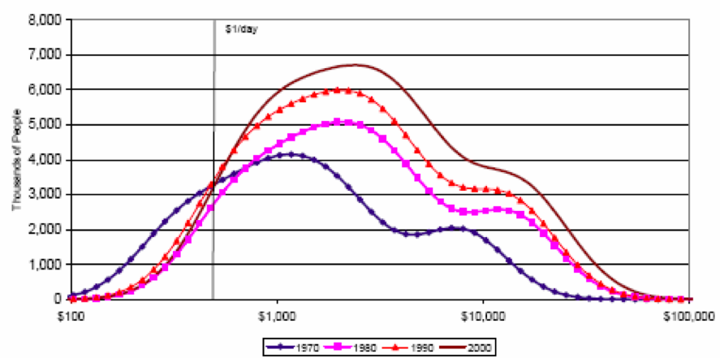Because large increases in income are usually associated with increases in inequality (Gastwirth 1972), it is not unexpected that the income distribution of most countries shifted upward during this time (Figure 3). Nor is it surprising that while aggregate income increased during this time, much of the population rose up and out of poverty[37] (Herrera 2012). As one of the so-called BRIC[38] countries, Brazil experienced massive economic growth during this time, and so it is also not surprising to see a significant decrease in the levels of poverty during this economic boom. Net of GDP and the Gini coefficient[39], the poverty headcount ratio alone dropped from over 35% to levels below 10% in the last 25 years while the depth of poverty (the poverty gap) dropped from 15% at its highest levels in the early 80’s to under 5% in 2010 (Figures 4 & 5).

Figure 3 — Economic Growth in the 20th Century (Herrera 2012)

Figures 4 & 5 — Poverty Levels in Brazil

(Vertical red lines indicate the implementation of the CCT program)

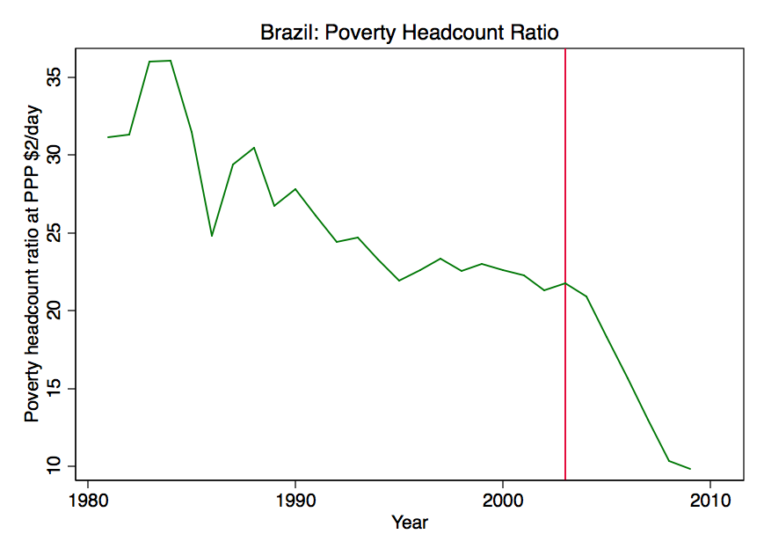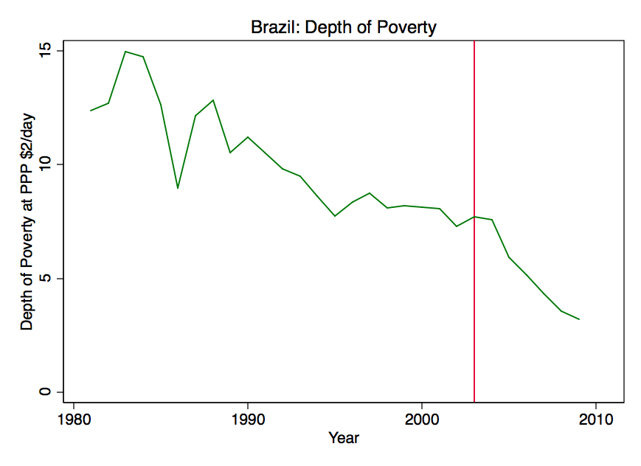

|  |  |  |  |  |
| --- | --- | --- | --- | --- |
| OLS of Poverty Metrics in Brazil | | | | |
|  | *Headcount Ratio (FGT0)* | | *Depth of Poverty (FGT1)* | |
| *GDP* | -0.0000159*** | (-3.88) | -0.00000443* | (-2.76) |
| *Gini Coefficient* | -0.143 | (-0.42) | -0.00440 | (-0.03) |
| *Year* | 0.0984 | (0.52) | -0.106 | (-1.33) |
| *N* | 29 | | 29 | |
| *t statistics in parentheses — *p<0.05, **p<0.01, *** p<0.001* | | | | |

Table 4 — Regressing Poverty Levels in Brazil

An important question to ask at this point is whether the rate of change in these poverty levels has changed and if so, whether it is different in the periods of time before and after the implementation of the CCT program, *Bolsa Família*. By comparing the rates of change of poverty level indicators in other countries — both with and without CCT programs — I test the null hypothesis that there is no difference between the rate of change in the poverty levels of a country with and a country without a CCT program.

Naïve Analysis

Figure 6 & 7 — Rates of Change in Poverty Levels in Brazil

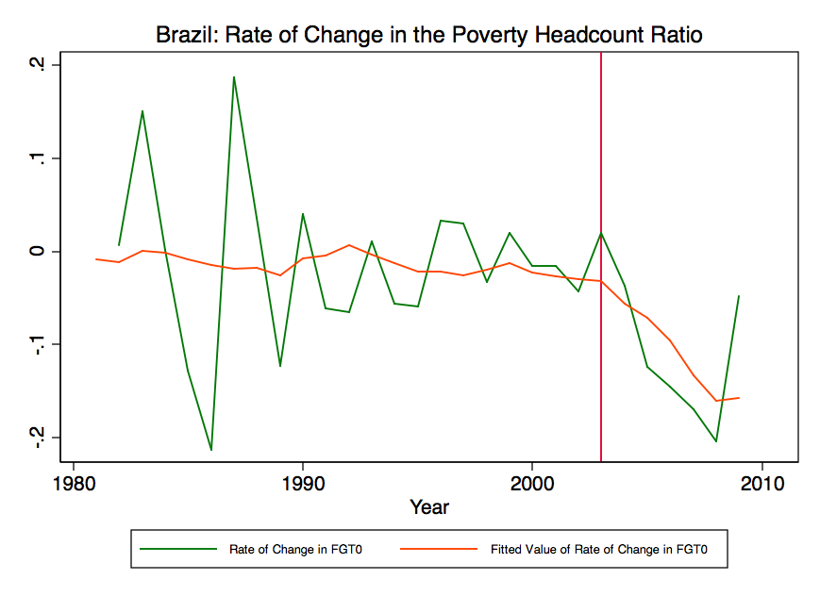 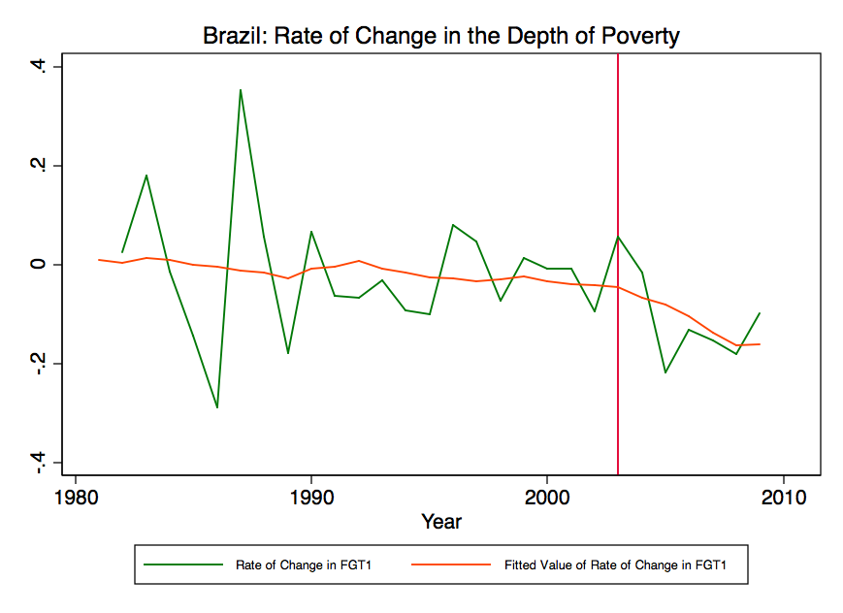

A glance at the rates of change in the poverty levels of Brazil shows that although the rate of change in poverty levels is highly volatile from year to year, the overall trend has a slope close to zero (Figures 6 & 7). The rate of change in the poverty headcount ratio in Brazil typically fluctuated between three and four percentage points in the mid eighties, as did the rate of change in the depth of poverty. During this time, however, it tended to fluctuate equally in magnitude above and below zero, resulting in a mean rate of change close to zero. The same analysis for the depth of poverty shows a similar pattern. Given these apparent trends in Brazil, it is of interest to examine these trends in the context of other Latin American countries (with and without CCT programs).

An analysis on the trends of the rates of change in poverty metrics between Brazil, Latin American countries with CCT programs and Latin American countries without CCT programs shows that the rate of change in poverty levels across countries with CCT programs in Latin America decreases roughly twice as fast as the trend for Brazil (Figures 8 & 9). The slope on this trend is -.0087 compared to -.0042, and it is certainly faster than Latin American countries without a CCT program[40].

Figure 8 & 9 — Trends on Rate of Change in Poverty Levels

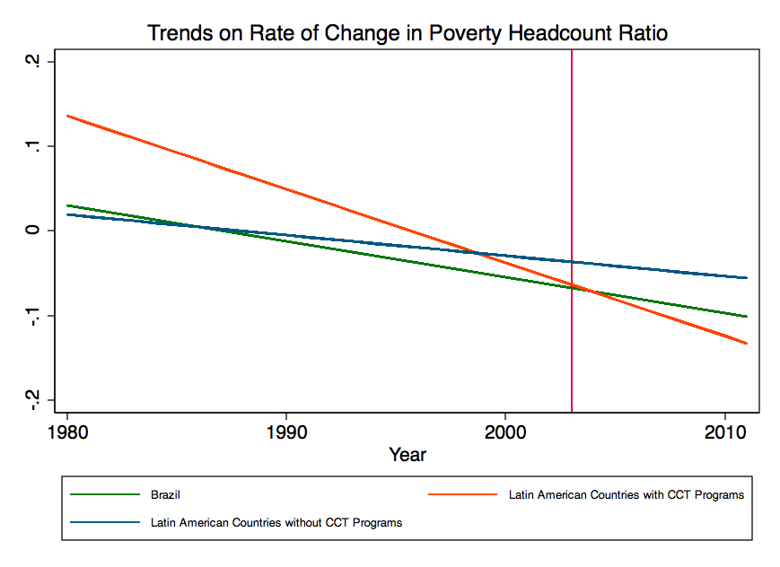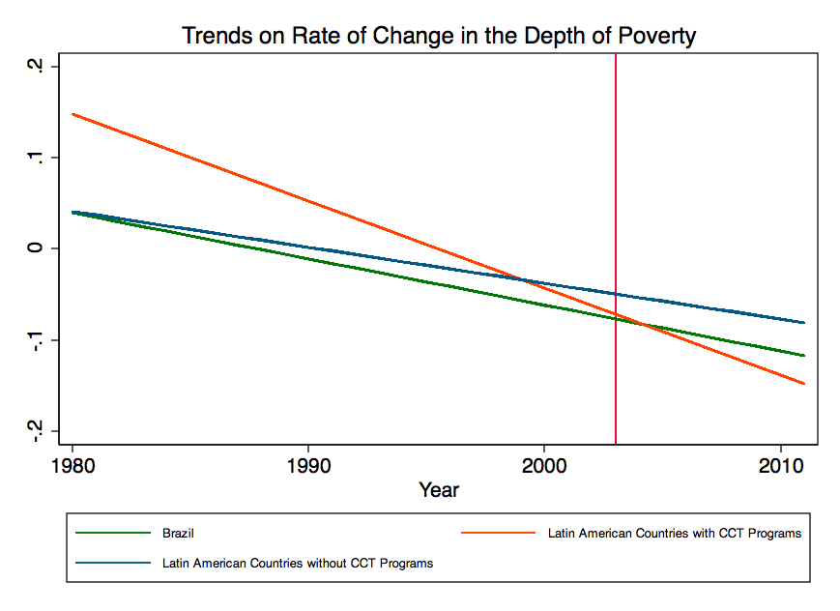

|  |  |  |  |
| --- | --- | --- | --- |
| Naïve Robust OLS Regression on the Log-Differences of the Poverty Headcount Ratio in Brazil | | | |
|  | *Brazil* | *Latin American CCT Programs* | *Latin American Non-CCT Programs* |
| *Year* | -0.00423* | -0.00866*** | -0.00243 |
| (-2.06) | (-5.66) | (-1.74) |
| *N* | 28 | 189 | 119 |
| *Naïve Robust OLS Regression on the Log-Differences of the Depth of Poverty in Brazil* | | | |
|  | *Brazil* | *Latin American CCT Programs* | *Latin American Non-CCT Programs* |
| *Year* | -0.00505 | -0.00956*** | -0.00393 |
| (-1.75) | (-4.62) | (-1.86) |
| *N* | 28 | 189 | 119 |
| *t statistics in parentheses — *p<0.05, **p<0.01, *** p<0.001* | | | |

Table 5 — Naïve Regressions on Log-Differences of Poverty in Brazil

The regression shows that there exists a significant difference over time in the rate of change of both poverty metrics in Brazil and in countries with CCT programs, whereas the same cannot be said for countries without CCT programs (Table 5). While these results provide encouraging evidence that CCT programs may be associated with decreases in poverty, the tests neither control for exogenous variables, nor do they account for the differences in the slope of the trend lines before and after the program, which the next phase of the analysis will examine.

# Analysis & Discussion

The final model is an OLS regression of the rate of change in poverty levels. It controls for GDP — which I have shown to be the most statistically significant factor in poverty reduction — as well as inequality and the stage of the CCT program[41]. By including dummy variables for each CCT stage in the model I observe how the rates of change in poverty differ at each stage of CCT program net of the other factors (Equation 1).

Equation 1 — OLS Model for Rates of Change in FGT

Brazil

A difference-in-differences analysis of the levels of poverty in Brazil from 1980 to 2011 (Table 6) reveals that prior to 2003, when *Bolsa Família* was consolidated from other CCT programs in Brazil, the mean rate of change in poverty had been reasonably stable. Net of GDP, the Gini coefficient and the other stages, the log difference of the poverty headcount ratio (which represents the slope of the rate of change)[42] dropped steadily by a statistically insignificant -.0093 over the course of the two decades preceding the implementation of the program. Although the graph shows much fluctuation in the metrics (particularly during the early nineties) the effective average annual rate of change before 2003 was extremely small, and the difference between the mean rate of change during this time period and the slope of the line from the OLS model predicting the rate of change was not statistically significant.

Table 6 — OLS Model of Log-Differences of Poverty in Brazil

|  |  |  |  |  |
| --- | --- | --- | --- | --- |
| OLS Model of CCT Programs and Poverty Metrics in Brazil | | | | |
|  | *Poverty Headcount Ratio* | | *Depth of Poverty* | |
| *Rate of Change of GDP* | -1.715*** | (-3.84) | -1.965** | (-3.01) |
| *Rate of Change in Gini Coefficient* | 1.902 | (1.87) | 2.191 | (1.34) |
| *Before CCT Program* | -0.00934 | (-0.16) | -0.0366 | (-0.35) |
| *Immediately After CCT Program* | -0.0568 | (-1.06) | -0.00281 | (-0.03) |
| *Intermediate Phases of CCT Program* | -0.0415 | (-1.33) | -0.0796* | (-2.65) |
| *intercept* | 0.0760** | (2.90) | 0.0881* | (2.21) |
| *N* | 28 | | 28 | |
| *t statistics in parentheses — *p<0.05, **p<0.01, *** p<0.001* | | | | |

After 2003, net of GDP and the Gini coefficient, the rate of change in poverty levels in Brazil begins to fall. In the first two years after the deployment of *Bolsa Família*, the rate of change falls by more than six times to -.0568 for the poverty headcount ratio. In these first two years after deployment, the rate of change in the depth of poverty did not fall, and in fact seems to have increased from -.0366 to -.00281. After the first two years, however, the rate of change in the poverty headcount ratio increased slightly, though it continued to be lower than before the program was implemented by a factor close to 4.5. The rate of change in the depth of poverty during this time fell dramatically to -.0796, more than twice what it had been before the program existed, and at a statistically significant p-value less than .05.

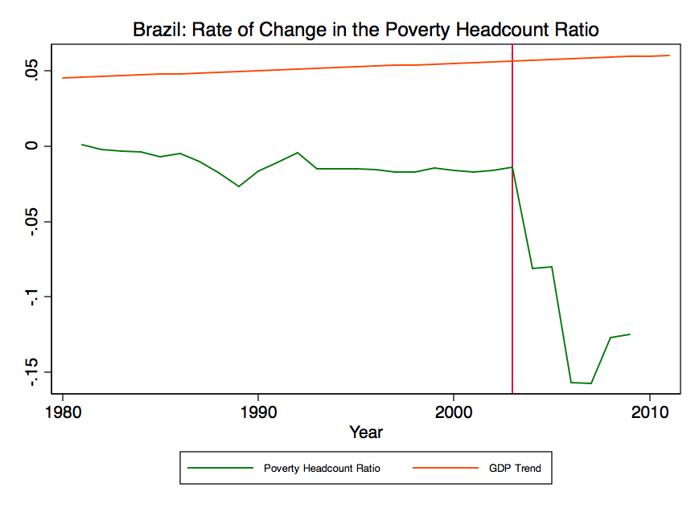

(Vertical red lines indicate the implementation of the CCT program)

Figures 10 & 11 — Splined Rates of Change in FGT0 and FGT1 in Brazil

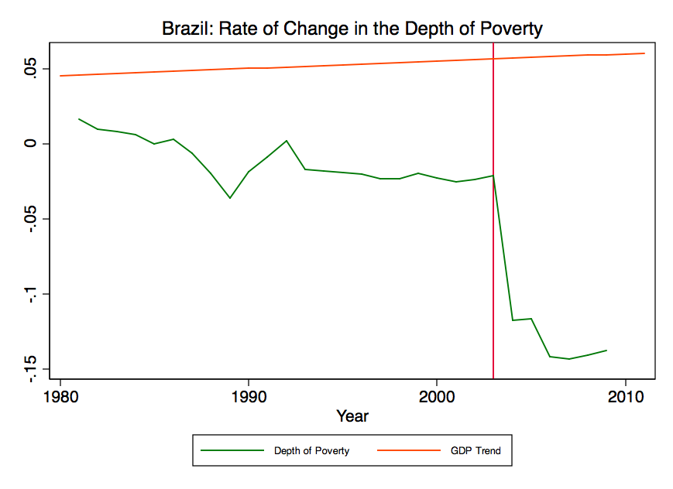

(Vertical red lines indicate the implementation of the CCT program)

The change is stark, and can be more easily understood visually by graphing the rate of change in poverty levels over time using a spline for each stage (Figures 10 & 11). The outcome is further illustrated by observing the trend for GDP at the same time. As the rates of change of both measures of poverty experience steep declines in the years immediately following the deployment of the CCT program, the GDP continues to grow at the same rate. The apparent fluctuation in the rate of change of poverty levels is dramatic, and so seemingly aligned with the CCT program’s start date that any skeptic should want to observe these trends in other countries.

Other Countries

In Mexico, where the *Progresa* CCT program was implemented in 1997 and later nationalized into *Oportunidades* in 2002, the trend on the rate of change in poverty levels follows similar patterns, falling abruptly at the onset of the program (Figure 12).

Figure 12 — Splined Rate of Change in FGT0 in Mexico

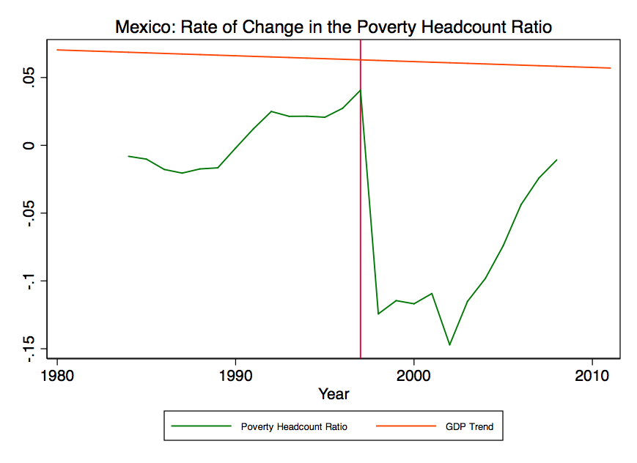Though still negative (and still less than it was before the implementation of the program), Mexico’s rate of change increased in the three years immediately following the program’s deployment in 1997. It dropped again in 2002 when the program was nationalized, but began increasing rapidly after that, almost reaching the levels at which it had been prior to the implementation of *Progresa*.

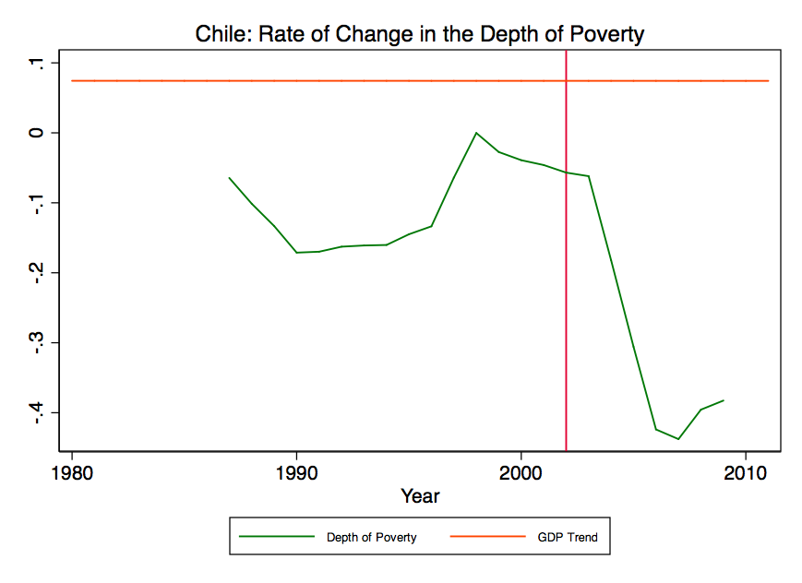Chile’s CCT program seems to have met with similar results (Figure 13). The rate of change in poverty levels dropped dramatically after the deployment of the program in 2002, but while they remained negative, and well below their original levels before the program’s implementation, there was an increasing trend in the two to three years after the program’s deployment. The depth of poverty looked similar, as it has in other analyses.

Figure 13 — Splined Rate of Change in FGT0 in Chile

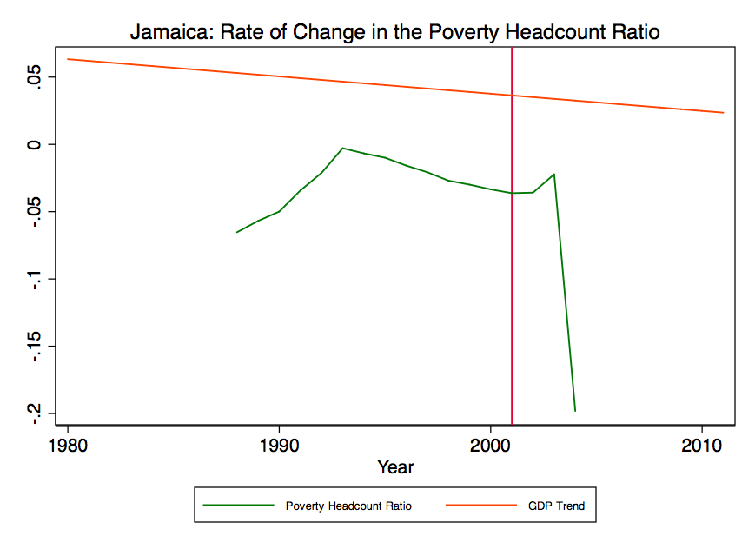In the Caribbean, Jamaica’s rate of change in poverty levels mostly agrees with the experience of the other countries in Latin America (Figure 14). In Jamaica’s case, it took roughly two years to begin seeing any results at all from the CCT program. Though the rate of change was already negative at the time the program was deployed, it increased slightly in the first two years, following which, there was a sharp decline in the rate of change of poverty levels. No upward swing has been detected since the program’s implementation.

Figure 14 — Splined Rate of Change in FGT0 in Jamaica

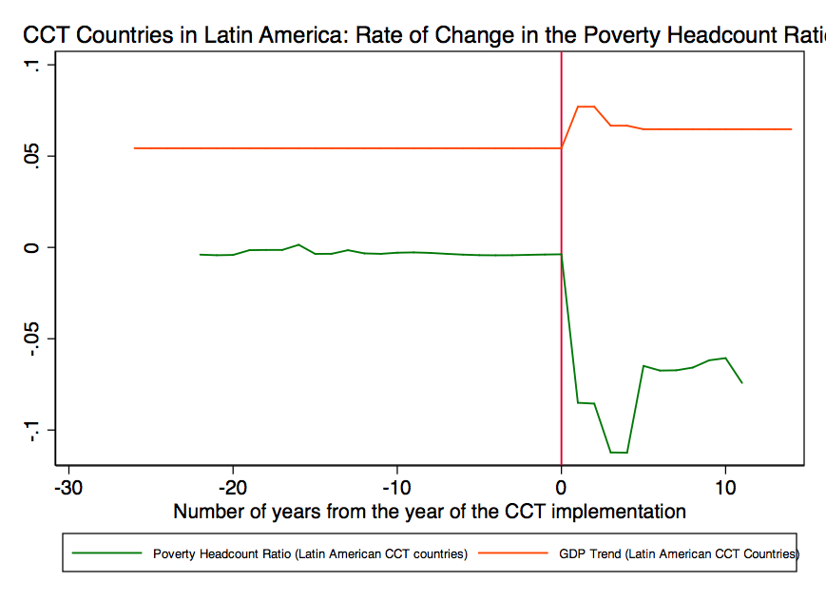It is possible that some latent characteristic of Jamaica is different from these other countries, or that some aspect of the Caribbean is different from Latin America in such a way as to exhibit the delayed fluctuation observed in Jamaica’s data. Aggregating country-level data by region shows how the results I’ve discussed from countries with CCT programs is not unusual (Figure 15).

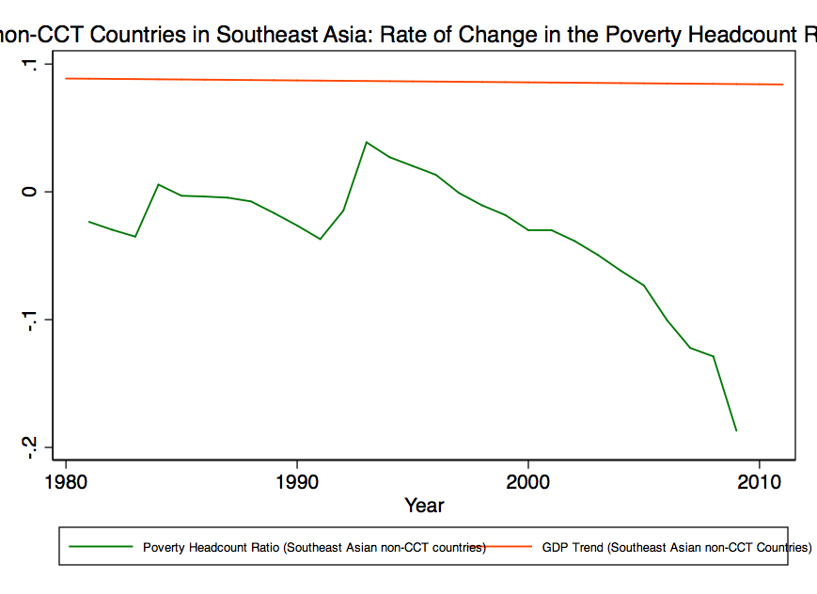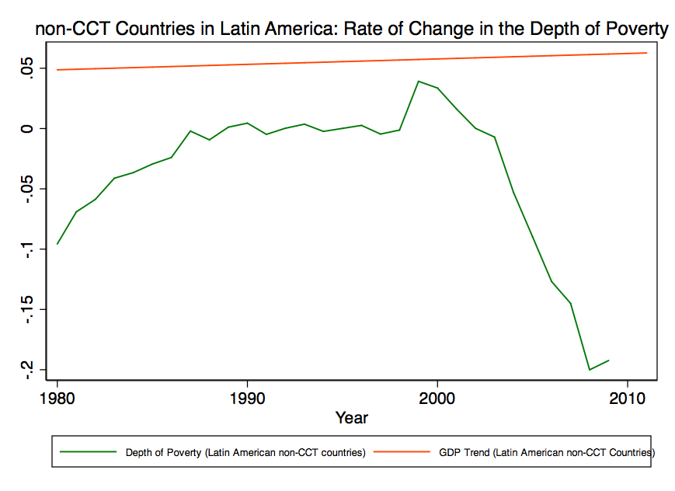

Figures 16 & 17 — Splined Aggregate Rates of Change in FGT0 for countries without CCT Programs (Asia & Latin America)

Compared to countries with CCT programs across the world, countries without CCT programs show a very different trend. While Latin American and Southeast Asian countries without CCT programs (Figures 16 & 17) exhibit decreasing rates of change in poverty levels, their fluctuations are not as drastic. In countries without CCT programs in various parts of Africa, the Caribbean, Eastern Europe, the Balkans and the Middle East, trends are even less obvious or suggestive of an event-based fluctuation (Figures 18, 19, 20 & 21).

Figures 18, 19, 20 & 21 — Splined Aggregate Rates of Change in FGT0 for countries without CCT Programs (West Africa, Caribbean, North Africa and the Middle East)

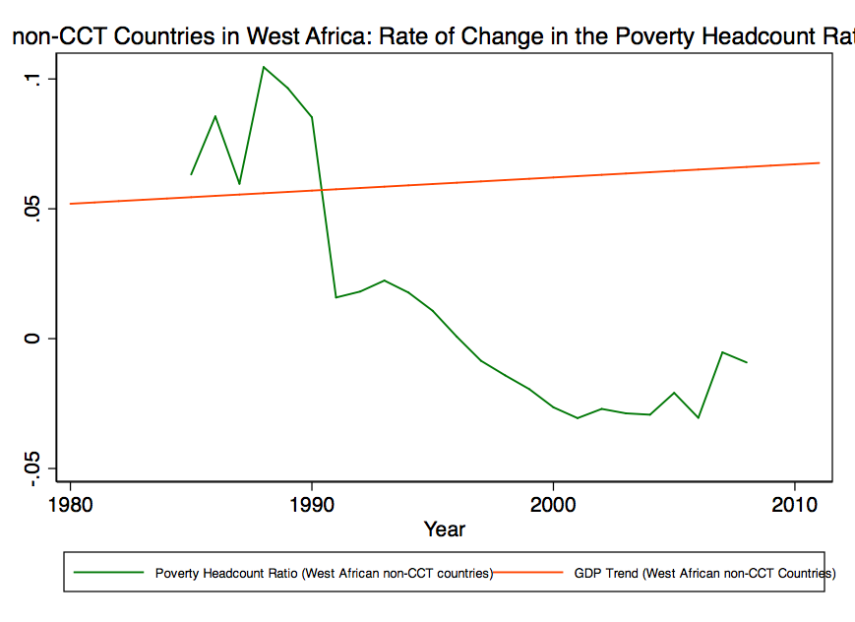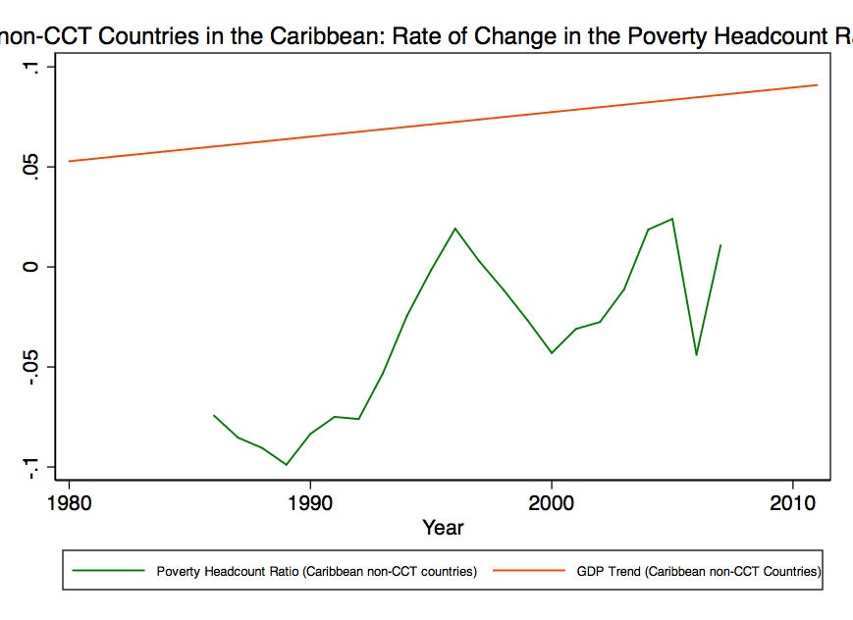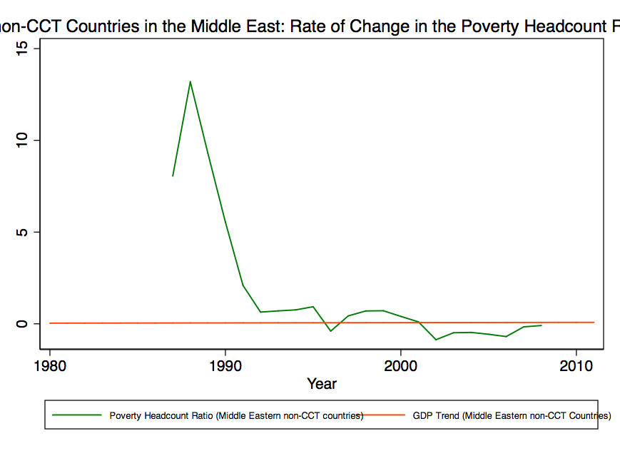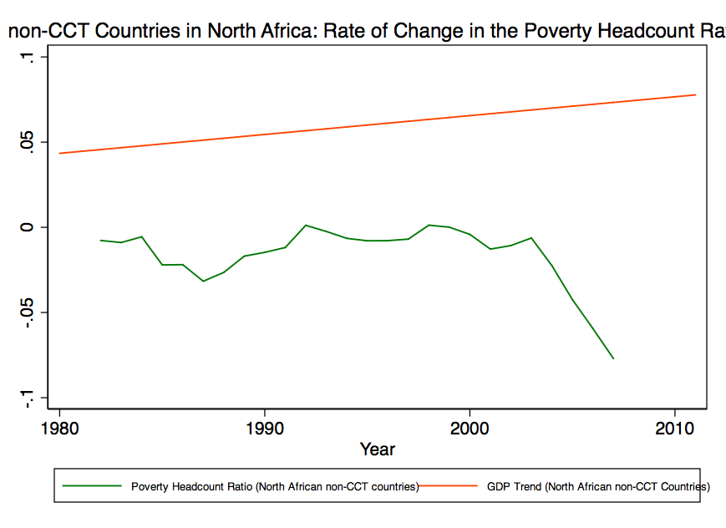

Discussion

The data I have established shows that the result observed in Brazil is not an outlier as similar trends are observed in other Latin American countries with CCT programs, as well as the Jamaican program in the Caribbean. Specifically, the data shows that the rates of change in poverty levels in countries that implement CCT programs exhibit similar fluctuation patterns after the deployment of the programs. Furthermore, it shows that while these countries exhibit similar fluctuations to countries without CCT programs before their deployment, the fluctuations observed thereafter are quite different from countries that have not deployed CCT programs.

What this analysis shows is that the rate of change in the poverty headcount ratio and the depth of poverty exhibits a measurable decline after the deployment of the *Bolsa Família* CCT program in 2003 (the rate of change in the depth of poverty by a statistically significant amount). That the other values are lower but statistically insignificant is not surprising at this point, given the program’s age. Even as the most developed of these programs, *Bolsa Família* is still less than a decade on in its development and only a relative handful of people will have left the program and attempted to face the world with their new levels of human capital. In the coming years, changes in the job market that reflect the new levels of human capital will be most telling.

As the country continues to grow and develop, there will be opportunities to observe how it adapts to the reality of a population that has been too poor in the past to help itself up but will now be able to study and work their way out of poverty and contribute to the direction of the country’s economy. If the trend continues there will be a shift in the demographics of the population, with more people available and capable of performing jobs previously out of their scope or reach. This change in the labor force will likely only be one of many facing the Brazilian economy, but observing these changes in particular should provide an interesting perspective on the effects of CCT programs.

Issues & Limitations

Several CCT studies have mentioned the nascent quality of the data as an area of concern (Oliveira et al. 2007; Fiszbein et al. 2009; Freije et al. 2006), and with reason. Many countries have only recently implemented CCT programs, and data were derived from either the pilot stages of these programs or from the early phases of the implementations (Fiszbein et al. 2009). Because their effects (if any are present) need time to manifest, I cannot necessarily expect to observe these effects clearly or conclusively so soon after implementation. However, with a few CCT programs at the time of this writing above the dozen year mark, and many approaching a decade, data available from the field is more cured than it has previously been, and even a couple of years can make a difference. Whereas Oliveira considered her two-year time-span to be too short to yield conclusive analysis, McKee performs a thorough analysis on data across a five-year span (McKee and Todd 2011). In a similar example based on data from 2007, a study by the ILO claimed that attempts to isolate the effects of the cash transfer on the aggregated household consumption level had not been successful (ILO 2009). Just two years later in 2009, however, Fiszbein et al. rather confidently used cumulative consumption data to isolate the effects of CCT programs on short-term poverty relief (Fiszbein et al. 2009). Because several CCT programs have, however, been in non-pilot operation for approximately a decade at the time of this writing, I expect data maturity will not be as relevant a concern as it has been in the past.

As in any observational study, data quality may come into question (Singleton and Straits 2010; World Bank 2012). When data is compiled from various sources[43] (however reliable those sources may be), this data inexorably lends itself to noise such as missing values or unknown biases. Unfortunately, the scope of this study does not include gathering complete data from all possible agencies that may have gathered them at some point, nor does it allow for the resources necessary to question the validity of the data-gathering processes used by such a broad class of potential data agents. In order to avoid criticism in this area, I keep my observations and analyses to the level of the data, and ask that the reader take my conclusions only as far as the data can be considered.

Lastly, because the environments in which CCT programs are deployed differ across the world, it is difficult to generalize the success or failure of one to that of another (Ravallion et al. 1991). Other political and cultural environments, for example, may have different influences on the outcome of a CCT program. In the analysis of poverty in Brazil, I attempted to control for the size and reach of the programs based on the aggregate number of people who received benefits and how much money the programs distributed. However, this data was not readily available for other countries, meaning that their analyses cannot control for these factors. Because I wish to compare the results of the analysis in Brazil to those in other countries, I choose to conduct the analysis ignoring program size and reach. In light of this, I have kept my conclusion focused on the outcome of a CCT program based on the rate of change in poverty levels over time in order to assert how well the model fares across the world. Future studies can advance this evaluation method by controlling for size and reach within all countries with CCT programs.

# Conclusion

Although poverty levels in Brazil have been in steady decline over time, I have observed a statistically significant decrease in the rate of change in poverty levels in Brazil following the deployment of the *Bolsa Família* CCT program. If the trend continues, the levels of poverty in the country as measured by both the percentage of people living below the poverty line as well as how deeply below the poverty line that percentage goes, it looks promisingly likely that the programs will be an asset in combating poverty in the long run. Furthermore, the short-term alleviation the program provides coupled with the improved social welfare metrics observed in other studies should provide increasing demand-side pressure for increased spending in the areas demanded including education and health care.

Many other studies have measured the ability of CCT programs to improve social welfare indicators for human capital development, and the literature shows a clear connection between CCT programs and improvements in education, health and consumption metrics. While some CCT programs have seemingly improved the situations in their respective environments, other studies have provided little conclusive evidence to show that the program’s long-term objectives can be met based on the available trends in poverty. By directly evaluating the rates of change in the levels of poverty, this study has provided more evidence that the long-term objectives of CCT programs are being met.

It has been my aim in this study to assert whether CCT programs can be associated with a decrease in the rates of change of poverty levels as measured explicitly by poverty metrics in order to assess whether CCT programs can fulfill their objective of decreasing poverty in the long run. By demonstrating this association in the *Bolsa Família* program in Brazil, as well as other countries and countries with CCT programs in general, I hope to lay the groundwork for other studies that can establish causal connections between CCT programs, increases in human capital and the reduction of poverty in the long term. A better understanding of this relationship will provide leaders and policy-makers with the knowledge to better formulate best practices for implementing successful CCT programs across various political, social and economic landscapes and ultimately determine whether CCT programs will become the cost-effective instrument of choice in the toolbox of policy makers, or if they will fade into history as a passing fad of the early millennium.

# References

Aber, J. Lawrence. 2012. “A Theory-based Evaluation of a Complex Antipoverty Strategy: Killing Two Birds with One Stone” February, New York University. http://steinhardt.nyu.edu/faculty_bios/view/J._Lawrence_Aber.

Attanasio, Orazio, Erich Battistin, Emla Fitzsimons, Marcos Vera-Hernandez, and Alice Mesnard. 2005. “How Effective Are Conditional Cash Transfers? Evidence from Colombia” (BN54) (January). http://www.ifs.org.uk/publications/3214.

Attanasio, Orazio, Emla Fitzsimons, Ana Gomez, Martha Isabel Gutierrez, Costas Meghir, and Alice Mesnard. 2008. “Children’s Schooling and Work in the Presence of a Conditional Cash Transfer Program in Rural Colombia.” *Economic Development and Cultural Change* 58 (2) (September): 181–210.

Attanasio, Orazio, and Alice Mesnard. 2006. “The Impact of a Conditional Cash Transfer Programme on Consumption in Colombia.” *Fiscal Studies* 27 (4) (December 1): 421–442. doi:10.1111/j.1475-5890.2006.00041.x.

Borraz, Fernando, and Nicolás González. 2009. “Impact of the Uruguayan Conditional Cash Transfer Program.” *Cuadernos De Economía* 46 (134) (November): 243–271. doi:10.4067/S0717-68212009000200006.

Bourguignon, François, and Satya Chakravarty. 2003. “The Measurement of Multidimensional Poverty.” *Journal of Economic Inequality* 1 (1): 25–49.

Bourguignon, François, Francisco H. G. Ferreira, and Phillippe G. Leite. 2003. “Conditional Cash Transfers, Schooling, and Child Labor: Micro-Simulating Brazil’s Bolsa Escola Program.” *The World Bank Economic Review* 17 (2) (December 1): 229 –254. doi:10.1093/wber/lhg018.

Bourguignon, François, Francisco Ferreira, and Phillippe Leite. 2002. *Ex-Ante Evaluation of Conditional Cash Transfer Programs: The Case of Bolsa Escola*. World Bank Publications. http://elibrary.worldbank.org.ezproxy.cul.columbia.edu/content/workingpaper/10.1596/1813-9450-2916.

Britto, Tatiana. 2005. *Recent Trends in the Development Agenda of Latin America: An Analysis of Conditional Cash Transfers*. Brazil: Ministry of Social Development. http://www.sed.man.ac.uk/research/events/conferences/documents/Social%20Protection%20Papers/Britto.pdf.

Caixa Economica Federal. 2012. “Bolsa Família.” *Caixa — Bolsa Família*. http://www.caixa.gov.br/voce/social/transferencia/bolsa_familia/index.asp.

Cardoso, Eliana, and André Portela Souza. 2004. “The Impact of Cash Transfers on Child Labor and School Attendance in Brazil.” *University of Vanderbilt* (April).

Dammert, Ana C. 2009. “Heterogeneous Impacts of Conditional Cash Transfers: Evidence from Nicaragua.” *Economic Development and Cultural Change* 58 (1) (October): 53–83. doi:10.1086/605205.

Dollar, David, and Aart Kraay. 2002. “Growth Is Good for the Poor.” *Journal of Economic Growth* 7 (3): 195–225. doi:10.1023/A:1020139631000.

Fan, Ming-Yu. 2008. “Missing Data Analysis – _Multiple Imputation” April, Stata Corp, UK.

Fernald, Lia, Paul Gertler, and Lynnette Neufeld. 2009. “10-year Effect of Oportunidades, Mexico’s Conditional Cash Transfer Programme, on Child Growth, Cognition, Language, and Behaviour: a Longitudinal Follow-up Study.” *The Lancet* 374 (09) (December): 61640–8. Community Health and Human Development, School of Public Health, University of California, Berkeley, CA, USA. doi:10.1016/S0140- 6736(09)61676-7.

Fiszbein, Ariel, Norbert Schady, Francisco H.G. Ferreira, Margaret Grosh, Nial Kelleher, Pedro Olinto, and Emmanuel Skoufias. 2009. *Conditional Cash Transfers: Reducing Present and Future Poverty*. Washington, D.C: World Bank. http://siteresources.worldbank.org/INTCCT/Resources/5757608-1234228266004/PRR-CCT_web_noembargo.pdf.

Foster, James, Joel Greer, and Erik Thorbecke. 1984. “A Class of Decomposable Poverty Measures.” *Econometrica* 52 (3) (May 1): 761–766. doi:10.2307/1913475.

Freije, Samuel, Rosangela Bando, Fernanda Arce, Carlos Medina, and Raquel Bernal. 2006. “Conditional Transfers, Labor Supply, and Poverty: Microsimulating Oportunidades.” *Brookings Institution* 7 (1) (October): 73–124.

Gastwirth, Joseph L. 1972. “The Estimation of the Lorenz Curve and Gini Index.” *The Review of Economics and Statistics* 54 (3): 306–316.

Gelman, Andrew, John Carlin, Hal Stern, and Donald Rubin. 2004. *Bayesian Data Analysis*. 2nd ed. Texts in Statistical Science. CRC press. http://books.google.com.ezproxy.cul.columbia.edu/books?hl=en&lr=&id=TNYhnkXQSjAC&oi=fnd&pg=PP1&dq=Bayesian+data+analysis+gelman&ots=5H2N9EBwN6&sig=T54u8CVWsmpF74ycNbqEJ_Ki0Lg#v=onepage&q=Bayesian%20data%20analysis%20gelman&f=false.

Gladwell, Malcolm. 2008. *Outliers: The Story of Success*. Little, Brown and Company. http://books.google.com.ezproxy.cul.columbia.edu/books?hl=en&lr=&id=3NSImqqnxnkC&oi=fnd&pg=PT2&dq=outliers+malcolm+gladwell&ots=248d95YPGA&sig=yDvy78kGmfBhjBMIH8xfEkaENj8.

Gledhill, John, and Maria Gabriela Hita. 2009. “New Actors, New Political Spaces, Same Divided City? Reflections on Poverty and the Politics of Urban Development in Salvador, Bahia.” *SSRN eLibrary* (September 30). http://papers.ssrn.com.ezproxy.cul.columbia.edu/sol3/papers.cfm?abstract_id=1544283.

Grantham-McGregor, Sally, Yin Bun Cheung, Santiago Cueto, Paul Glewwe, Linda Richter, and Barbara Strupp. 2007. “Developmental Potential in the First 5 Years for Children in Developing Countries.” *The Lancet* 369 (9555) (January 6): 60–70. doi:10.1016/S0140-6736(07)60032-4.

Grindle, M.S., and J.W. Thomas. 1991. “Public Choices and Policy Change: The Political Economy of Reform in Developing Countries.” *Recherche* 67: 02.

Grosh, Margaret, Carlo del Ninno, Emil Tesliuc, Azedine Ouerghi, Annamaria Milazzo, and Christine Weigand. 2008. “For Protrection and Promotion.” *World Bank*. doi:10.1596/978-0-8213/7581-5. http://elibrary.worldbank.org.ezproxy.cul.columbia.edu/docserver/download/9780821375815.pdf?expires=1328377614&id=id&accname=ic_columbia&checksum=559D67D6945A460E81C38AE3DB543B30.

Handa, Sudhanshu, and Benjamin Davis. 2006. “The Experience of Conditional Cash Transfers in Latin America and the Caribbean.” *Development Policy Review* 24 (5): 513–536.

Herrera, Helios. 2012. “Poverty & the Economy.”

Honaker, James, and Gary King. 2010. “What to Do About Missing Values in Time‐Series Cross‐Section Data.” *American Journal of Political Science* 54 (2) (April 1): 561–581. doi:10.1111/j.1540-5907.2010.00447.x.

ILO. 2009. “Bolsa Familia in Brazil: Context, Concept and Impacts.” http://www.ilo.org/public/libdoc/jobcrisis/download/109B09_28_engl.pdf.

Johannsen, Julia. 2009. *Conditional Cash Transfers in Latin America: Problems and Opportunities*. Social Protection and Health Division — Inter-American Development Bank. http://www.adb.org/documents/events/2009/high-level-social-assistance/Johannsen-Conditional-Cash-Transfers.pdf.

Junninen, Heikki, Harri Niska, Kari Tuppurainen, Juhani Ruuskanen, and Mikko Kolehmainen. 2004. “Methods for Imputation of Missing Values in Air Quality Data Sets.” *Atmospheric Environment* 38 (18) (June): 2895–2907. doi:10.1016/j.atmosenv.2004.02.026.

Lindert, Kathy, Anja Linder, Jason Hobbs, and Bénédicte de la Brière. 2007. “The Nuts and Bolts of Brazil’s Bolsa Família Program: Implementing Conditional Cash Transfers in a Decentralized Context.” *World Bank Social Protection Discussion Paper* 709. http://siteresources.worldbank.org/INTLACREGTOPLABSOCPRO/Resources/BRBolsaFamiliaDiscussionPaper.pdf.

Lindert, Kathy, and Vanina Vincensini. 2008. “Uma Análise Do Tratamento Dado Pela Mídia Às Transferências Condicionadas De Renda (TCR) No Brasil” presented at the World Bank, July, Washington, DC. http://siteresources.worldbank.org/INTLACBRAZILINPOR/Resources/ApresentacaoInternet.pdf.

Mankiw, N. Gregory. 2010. *Macroeconomics*. 7th ed. Worth Publishers.

Marchenko, Yulia. 2009. “Multiple-imputation Analysis Using Stata’s Mi Command” presented at the UK Stata Users Group Meeting, September, Stata Corp, UK. http://biostat.mc.vanderbilt.edu/wiki/pub/Main/QingxiaChen/MI_stata.pdf.

McKee, D., and P.E. Todd. 2011. “The Longer-term Effects of Human Capital Enrichment Programs on Poverty and Inequality: Oportunidades in Mexico.” *Estudios De Economía* 38 (1): 67–100.

MDS. 2012. “Bolsa Família - MDS”. Government. *Bolsa Família — Ministério Do Desenvolvimento Social e Combate à Fome*. http://www.mds.gov.br/bolsafamilia.

Moore, Charity. 2009. “Nicaragua’s Red De Protección Social: An Exemplary but Short-lived Conditional Cash Transfer Programme.” *International Policy Centre for Inclusive Growth* 17 (January). www.ipc-undp.org/pub/IPCCountryStudy17.pdf.

O’Neill, J., and S. Goldman. 2001. *Building Better Global Economic BRICs*. Goldman Sachs.

Oliveira, A., MV Andrade, ACC Resende, CG Rodrigues, LR Souza, and RP Ribas. 2007. “Primeiros Resultados Da Analise Da Linha De Base Da Pesquisa De Avaliacao De Impacto Do Programa Bolsa Familia.” *Vaitsman J, Paes-Sousa R, Organizadores. Avaliação De Políticas e Programas Do MDS: Resultados* 2.

ONYC. 2012. “Opportunity NYC”. Government. http://opportunitynyc.org/about.

Pogge, T., and S. Reddy. 2005. “How Not to Count the Poor.”

Ravallion, Martin. 1992. “Poverty Comparisons.” *Living Standard Measurement Study Working Paper* 88.

———. 2008. *Which Poverty Line?* World Bank International Poverty Centre.

Ravallion, Martin, Shaohua Chen, and Prem Sangraula. 2008. “Dollar a Day Revisited”. World Bank Development Research Group. http://www-wds.worldbank.org/external/default/WDSContentServer/IW3P/IB/2008/09/02/000158349_20080902095754/Rendered/PDF/wps4620.pdf.

Ravallion, Martin, Gaurav Datt, Domirique Van De Walle, and Elaine Chan. 1991. “Quantifying the Magnitude and Severity of Absolute Poverty in the Developing World in the Mid-1980s.” *Policy Research Working Paper* 587.

Rawlings, Laura B. 2004. *A New Approach to Social Assistance : Latin America’s Experience with Conditional Cash Transfer Programs*. Social Protection Discussion Papers. The World Bank. http://www-wds.worldbank.org/servlet/WDSContentServer/WDSP/IB/2004/10/12/000012009_20041012095621/Rendered/PDF/301650PAPER0SP00416.pdf.

Rawlings, Laura B., and Gloria M. Rubio. 2005. “Evaluating the Impact of Conditional Cash Transfer Programs.” *The World Bank Research Observer* 20 (1): 29 –55. doi:10.1093/wbro/lki001.

Rubin, Donald. 1987. *Multiple Imputation for Nonresponse in Surveys*. Vol. 519. Wiley Online Library.

———. 1996. “Multiple Imputation After 18+ Years.” *Journal of the American Statistical Association* 91 (434) (June): 473–489. doi:10.2307/2291635.

Schultz, T. Paul. 2004. “School Subsidies for the Poor: Evaluating the Mexican Progresa Poverty Program.” *Journal of Development Economics* 74 (1): 199–250.

Singleton, Royce, and Bruce Straits. 2010. *Approaches to Social Research*. 5th ed. Oxford University Press.

The Economist. 2008. “Brazil: Happy Families.” *The Economist*, February 7. http://www.economist.com/node/10650663?story_id=10650663.

UNDP. 2009. “Conditional Cash Transfer Schemes for Alleviating Poverty: Relevance for India.” http://www.undp.org.in/content/cct/CCT_DP.pdf.

Wooldridge, Jeffrey. 2009. *Introductory Econometrics*. 4th ed. South-western CENGAGE Learning.

World Bank. 2012. “Poverty Analysis”. NGO. *Learning Materials from the World Bank Institute*. http://web.worldbank.org/WBSITE/EXTERNAL/TOPICS/EXTPOVERTY/EXTPA/0,,contentMDK:20243017~menuPK:435069~pagePK:148956~piPK:216618~theSitePK:430367~isCURL:Y,00.html.

World Bank Data. 2012. “Data | The World Bank.” http://data.worldbank.org/.

# Appendix

Foster-Greer-Thorbecke Index of Poverty

The following definitions and assertions are taken from the seminal paper defining this metric (Foster, Greer, and Thorbecke 1984).

Figure 15 — Splined Aggregate Rate of Change in FGT0 in Latin America

FGT0 — The headcount index is given by the general FGT form with α=0, which reduces FGT0 to . This figure measures the proportion of a population that is considered poor based on a selected poverty line[44]. This measure is common because it is easy to understand and measure. The measure does not, however, indicate the extent or depth of poverty.

FGT1 — The poverty gap index is given by the general FGT form with α=1, reducing it to , and measures the extent to which people fall below the poverty line. The sum of these gaps gives the minimum cost of eliminating poverty if transfers were perfectly targeted. The measure does not, however, reflect changes in inequality among the poor.

FGT2 — The poverty severity index is given by the general FGT form with α=2, which averages the squares of the gaps relative to the poverty line.

FGTSST — An aggregate of the three FGT metrics, the Sen-Shorrocks-Thon metric is given by , where *FGT0* is the headcount index, *FGT1* is the poverty gap index only for the poor population, and *GP* is the Gini index for poverty gaps for the population. It gives a single number that can be broken down to assert relative measures in the number of poor, the depth of their poverty and the level of inequality among them.

1. Although some countries had anti-poverty schemes at this time they were not, strictly speaking, CCT programs.
2. The scope of these interests spans a broad range, from investments and publicity to replication, innovation or humanitarian philanthropy to just pure scholarship.
3. Examples of indicators that most studies use to show successful outcomes include school enrollment rates, progression to secondary education, visits to primary care facilities for preventive health services, infant mortality and vaccinations (UNDP 2009; Schultz 2004; Attanasio et al. 2005).
4. Such as increasing school enrollment or for reducing infant mortality rates (Grantham-McGregor et al. 2007; Schultz 2004; UNDP 2009; Grosh et al. 2008).
5. These direct cash transfers are made with the expectation that people will make the best spending & investing decisions for themselves (François Bourguignon, Ferreira, and Leite 2002).
6. Many programs, such as *Bolsa Família* in Brazil, make the matriarch of the household (when one is available) the primary beneficiary. This has the added function of elevating the status of women within a society, as well as giving poor men — who tend to be more disconnected from the family unit — an incentive to remain attached to the family structure, if only to reap the rewards (Attanasio and Mesnard 2006).
7. ONYC was modeled after Brazil’s *Bolsa Família* program.
8. Examples of non-CCT programs include Medicaid in the United States, as well as food stamps and rice subsidies around the world.
9. The benefits distributed by *Bolsa Escola*, *Bolsa Alimentação*, *Cartão Alimentação* and *Auxílio-Gás* were integrated and exclusively distributed by *Bolsa Família* (Caixa Economica Federal 2012).
10. Brazil’s *Bolsa Família* reached 11.1 million people in 2011, almost 25% of the country’s population (Lindert et al. 2007).
11. Resource poverty, which is defined as not having enough resources or abilities today to meet a person’s needs is the primary form of poverty considered in most studies. Inequality is usually measured by the Gini Coefficient and vulnerability is defined as the probability today of being in or falling deeper into poverty in the future (World Bank 2012).
12. World Bank data is based on primary household surveys distributed by various third-party agencies as well as government statistical agencies and World Bank country departments (World Bank Data 2012)
13. The general form of the FGT index is given by where *N* is the population, *H* is the number of poor, *z* is the poverty line, *yi* are individual incomes and α is a sensitivity parameter. If α is low the FGT metric weights all the individuals with incomes below *z* roughly the same. If it is high, those with the lowest incomes (farthest below *z)* are given more weight in the measure (Foster, Greer, and Thorbecke 1984).
14. Which, curiously, is known to be a potential indicator for future earnings.
15. The metric accounts for increased spending on children’s clothes and higher quality food while ensuring that there is not an increase in adult consumables such as alcohol, tobacco or adult clothing (Attanasio and Mesnard 2006).
16. Despite their similarities in certain measures, Brazil and Argentina are quite different in others. Brazil’s poverty headcount ratios have often been anywhere from 2 to 20 times that of Argentina, with a Gini coefficient 10 to 20 points higher (World Bank Data 2012).
17. For example, by means of common acts of citizenship such as not throwing trash on the street, being courteous to the elderly and so forth.
18. For a more detailed explanation of the FGT statistical index, see the appendix.
19. The data has some limitations including having some regressions controlling for other correlates, some data existing for one year only while others exist for a range of years and in some cases, from the survey being given out too soon after the start of the program (Fiszbein et al. 2009).
20. I will admit the pun only in a footnote. All discussions in a master’s thesis are academic.
21. It should be noted that the costs of receiving this income might result in no fluctuation in the poverty level, or even a slight increase. If a child who would otherwise be working, for example, needed to be in school in order for the family to receive benefits, this could reduce the family’s overall income (François Bourguignon, Ferreira, and Leite 2002).
22. These data include education, government health and general indicators related to poverty such as the number of children out of school, the primary education completion rate, gross domestic product, average consumer expenditure, infant mortality rate, life expectancy at birth, the number of children under five receiving DPT or measles immunizations, population growth rate and other measures of interest to studies of poverty (Attanasio et al. 2005; Attanasio et al. 2008; Attanasio and Mesnard 2006; François Bourguignon, Ferreira, and Leite 2003; Britto 2005; Cardoso and Souza 2004; Dollar and Kraay 2002; Fiszbein et al. 2009; Grosh et al. 2008; Schultz 2004; UNDP 2009).
23. Though data is occasionally available as far back as the 1960’s, data for the indicators of interest in this study are only reliably available starting from about 1980.
24. These groupings include Latin America, the Caribbean, Eastern Europe, the Balkans, the Middle East, Southeast Asia, and West, North and Sub-Saharan Africa for countries with and without CCT programs.
25. As such, multiple imputation is more flexible than fully parametric methods such as maximum-likelihood or purely Bayesian analysis, and more efficient than list-wise deletion, correcting for potential bias, accounting for missing-data uncertainty and thus avoiding the underestimation of variances of estimates (Honaker and King 2010; Rubin 1996).
26. The duration of primary school varies between countries in this study, with a range of 3 to 8 years, and an average of 5.4. Brazil’s primary school system was 4 years long during the time period from 1980 to 2011.
27. I elect to use the DPT and Measles immunization rate indicators for children under five as the measures of preventive health in this study. Most countries had very complete records of these two indicators and because these diseases are prevalent around the world there exists no bias for region.
28. These factors are discussed in the next section.
29. I do not consider these exogenous factors, but rather indicators that are quite interrelated with the rate of change in poverty levels.
30. Mexico is a fair comparison to Brazil in this case because the Mexican CCT program, *Oportunidades*, reaches a similar proportion of the population and is at least as well regarded as *Bolsa Família* in terms of successful outcomes (Freije et al. 2006).
31. A sample of these includes Poland from 1993 to 1996, Moldova from 1998 to 2001, Macedonia in 2000 and Belarus from 1996 to 1997.
32. For this study I make the assumption that three years is enough time to begin seeing in some subjects the kind of effects expected in the long-term.
33. The Gini coefficient is a common metric for the index of inequality in a country, and is given in either ratios or whole numbers. The higher the number, the more unequally distributed is the wealth in the country. Brazil’s Gini coefficient has been one of the highest in the world at .583 while countries like the US, the UK and Germany have typically hovered around the upper 30’s (Herrera 2012).
34. Models 1 – 4 are shown to isolate the effects of using one factor at a time (in conjunction with time).
35. Idem.
36. *Bolsa Escola*, or School Grants was essentially *Bolsa Família* without the vaccination requirement. *Auxílio Gás*, or Auxiliary Gas,provided aid to families struggling to pay for stove propane. *Cartão Alimentação*, or Nutrition Card,provided families with nutritional aid (MDS 2012).
37. …while making a smaller proportion of the population that much richer.
38. Brazil, Russia, India, China, the explosively emerging economies in the world (O’Neill and Goldman 2001).
39. The two factors are correlated with a measure of .25, which is insignificant enough to consider both in the analysis (Wooldridge 2009).
40. Though the rate of change in the poverty headcount ratio for Latin American countries without CCT programs is roughly half of Brazil’s rate of change (-.0024 compared to -.0042), it is not statistically significant.
41. I’ve modeled the stages as *Before CCT Program Deployment*, *Phase 1* (first two years) and *Phase 2* (after two years).
42. Also known as the log difference, or the rate of change. Taking logs of variables with wide ranges such as population or school enrollment narrows the range of the variable, in some cases by a considerable amount, making estimates less sensitive to outlying observations on the variables. Variables that are proportion or a percentage (unemployment, poverty headcount ratio, etc.) are usually seen in level forms because any regression coefficients involving the original variable will have a percentage point change interpretation (Wooldridge 2009).
43. As I’ve mentioned, the World Bank data in this study is a consolidation of several databases, including other NGOs such as the UN, the IMF, the FAO, the OECD and others.
44. In this study I focus on a PPP $2/day poverty line, as it is more relevant to lower-middle income countries.